­­



Submitted to

:

Sir. AQIB ADEL

Lab Report

***BS***

***-***

***Software Engineering***

***1***

***ST***

***-***

***E***

Title: ALL LAB Report

IICT

Hamza Mehmood

Roll# SP-21-110

NUML

-

S21

-

2352

9



**National University of Modern Languages**

IICT

# ALL LAB REPORTS

**National University of Modern Languages Sector H-9, Islamabad, Pakistan.**



**Department of Software Engineering**

**Course Title: Introduction to Information & Computer Technology**

**Student Name: Hamza Mehmood**

**Roll Number: SP-21-110**

**Lab Number: WEEK 1-12 Date: 1 March to 3 June**

**Lab Assessment Rubrics**

**Method:** Lab report and instructor observation during Lab Session **Outcome Assessed:**

1. Ability to analyze and design solutions to conduct experiments (Psychomotor).
2. Ability to perform in a team (Affective).
3. Ability to apply and comprehend modern engineering tools to develop skills for engineering knowledge and being able to design report and documentation (Psychomotor).

|  |  |  |  |  |
| --- | --- | --- | --- | --- |
| **Performance** | **Exceeds Expectation (4-5)** | **Meets Expectation (2-3)** | **Does not meet Expectation (1)** | **Marks** |
| 1. Realization of  Experiment [c] | Chooses the required yet relevant equipment to perform the experiment establishes setup diagrams of equipment connection or wiring. | Effective guidance is required to choose relevant tools for the experiment and also to develop well connected wiring diagram. | Fails to select the required equipments/ tools to perform the experiment or wiring diagram seriously lack clarity or appear ambiguous. |  |
| 2. Teamwork [b] | An active cooperation develops among group members to support the execution of the experiment. | Effectively cooperates with the group members  to perform the experiment. | Negatively affects the other group members and creates hindrance in successful performance or completion of experiment. |  |
| 3. Conducting Experiment [a] | A careful selection of equipment, wiring is done under supervision of instructor for effective operation and task completion. | Carefully examines the  equipment, wiring of all components and calibrate experiments with very few errors. | Incapable of calibrating the suitable equipment and wiring with inaccurate equipment operation. |  |
| 4. Laboratory  Safety Rules [a] | Safety rules and procedures are carefully observed during the experiment. | Scrutiny observes the prescribed safety measures with very minor deviation. | Does not observe the safety rules during experiments. |  |
| 5. Data Collection  [a] | Data collection is carefully planned to achieve experimental objective. | Data collection is carefully planned to get experimental objectives with very minor mistakes. | Incapable of planning the data collection to acquire the experimental objective or the collected data is inappropriate or incomplete. |  |
| 6. Report writing  [c] | Properly written with all results. | Writing report with minor error. | Incomplete Lab report |  |

**Total Marks Obtained:**

**Instructor’s Signature:**

**National University of Modern Languages**

Microsoft Office: Word for Windows

# WEEK 1 (1-3-2021)

Introduction to lab:

*A word processor is a computer program used to create and print text documents that might otherwise be prepared on a typewriter. The key advantage of a word processor is its ability to make changes easily, such as correcting spelling, adding, deleting, formatting and relocating text. Once created, the document can be printed quickly and accurately saved for later modifications.*

**Given below are the basic functions of Microsoft Word:**

* Creating text documents.
* Editing and Formatting the existing documents.
* Making a text document interactive with different features and tools.
* Graphical documents, comprising images.
* Used by Authors and Researchers.
* Detect grammatical errors in a text document.

In first lab we have learnt the clipboard.



1. Move the cursor to the spot where you want to paste an item from the Word Clipboard.
2. Click the Word Clipboard icon. The Word Clipboard pane appears.

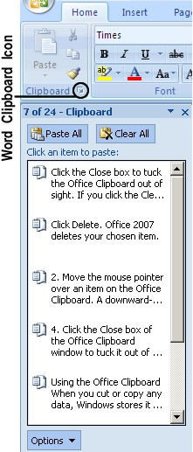

* 1. Move the mouse pointer over an item on the Word Clipboard. A downwardpointing arrow appears to the right. A pop-up menu appears and click Delete. Word 2016 deletes your chosen item.
  2. Click the Close box to tuck the Word Clipboard out of sight.

If you click the Clear All button, you can delete every item currently stored on the Office Clipboard. Make sure you really want to delete an item from the Office Clipboard because after you delete it, you cannot retrieve it.

**Uses of clipboard:**

When you cut or copy any data, Windows stores it in a special part of memory called the Clipboard.

The two big advantages of the Office Clipboard are:

* + You can store up to 24 items. The Windows Clipboard can store only one item.
  + You can select what you want to paste from the Clipboard. The Windows Clipboard lets you paste only the last item cut or copied.

**FONT:**

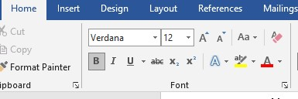

In the Fonts group, click the dialog box launcher button.

The button is found in the lower-right corner of the Font group

The Font dialog box’s Advanced tab hosts options for changing the size and position of text on a line.

The Set as Default button in the Font dialog box is used to change the font that

Word uses for a new document. If you prefer to use a specific font for all your documents, choose the font (plus other text attributes) in the Font dialog box, and then click the Set as Default button. In the dialog box that appears, choose the option All Documents Based on the Normal Template, and then click the OK button. Afterward, all documents start with the font options you selected

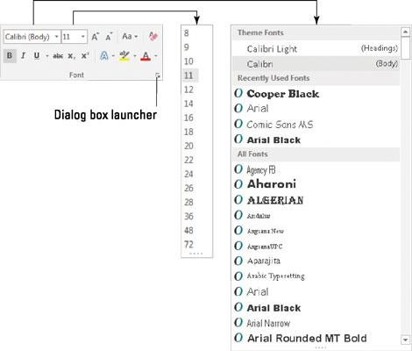

You can change font size and font style by using the font menu as shown above .

For example I want to change the size and style of dummy text below by using font menu:

Video provides a powerful way to help you prove your point. When you click Online Video, you can paste in the embed code for the video you want to add. You can also type a keyword to search online for the video that best fits your document.

To make your document look professionally produced, Word provides header, footer, cover page, and text box designs that complement each other. For example, you can add a matching cover page, header, and sidebar. Click Insert and then choose the elements you want from the different galleries.

I have applied the Algerian text on above document and size is 11 .

By using font menu we can also change the color of selected text.

For change the color of text:

1. Selected the text which you want to change the color.
2. Then go to font menu.
3. Then click on the font menu and where [A] is written from there we can change the color of text.
4. For example we want to change the color of this dummy text below.

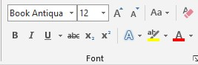

Video provides a powerful way to help you prove your point. When you click Online Video, you can paste in the embed code for the video you want to add. You can also type a keyword to search online for the video that best fits your document.

To make your document look professionally produced, Word provides header, footer, cover page, and text box designs that complement each other. For example, you can add a matching cover page, header, and sidebar. Click Insert and then choose the elements you want from the different galleries.

Bold Italic Underline



**Bold:**

**with the use of bold text we can bold our selected text.**

**Italic:**

*with the use of italic option we can change our selected text into italic text.*

**Underline:**

with the use of underline option we can make a underline our selected text.



Subscript superscript

1. **Subscript** is the text which a small letter/number is written after a particular letter/number. It hangs below its letter or number. It is used when writing chemical compound. An example of subscript is N2.
2. **Superscript** is the small letter / number above a particular letter / number. An example of superscript is 25. The number 5 above the number 2 is an example of superscript.

Superscript can be used for exponents in mathematics.

# WEEK 2 (8-3-2021)

**National University of Modern Languages Sector H-9, Islamabad, Pakistan.**



**Department of Software Engineering**

**Course Title: Introduction to Information & Computer Technology**

**Student Name: Hamza Mehmood**

**Roll Number: SP-21-110**

**Lab Number: WEEK 1-12 Date: 1 March to 3 June**

**Lab Assessment Rubrics**

**Method:** Lab report and instructor observation during Lab Session **Outcome Assessed:**

1. Ability to analyze and design solutions to conduct experiments (Psychomotor).
2. Ability to perform in a team (Affective).
3. Ability to apply and comprehend modern engineering tools to develop skills for engineering knowledge and being able to design report and documentation (Psychomotor).

|  |  |  |  |  |
| --- | --- | --- | --- | --- |
| **Performance** | **Exceeds Expectation (4-5)** | **Meets Expectation (2-3)** | **Does not meet Expectation (1)** | **Marks** |
| 1. Realization of  Experiment [c] | Chooses the required yet relevant equipment to perform the experiment establishes setup diagrams of equipment connection or wiring. | Effective guidance is required to choose relevant tools for the experiment and also to develop well connected wiring diagram. | Fails to select the required equipments/ tools to perform the experiment or wiring diagram seriously lack clarity or appear ambiguous. |  |
| 2. Teamwork [b] | An active cooperation develops among group members to support the execution of the experiment. | Effectively cooperates with the group members  to perform the experiment. | Negatively affects the other group members and creates hindrance in successful performance or completion of experiment. |  |
| 3. Conducting Experiment [a] | A careful selection of equipment, wiring is done under supervision of instructor for effective operation and task completion. | Carefully examines the  equipment, wiring of all components and calibrate experiments with very few errors. | Incapable of calibrating the suitable equipment and wiring with inaccurate equipment operation. |  |
| 4. Laboratory  Safety Rules [a] | Safety rules and procedures are carefully observed during the experiment. | Scrutiny observes the prescribed safety measures with very minor deviation. | Does not observe the safety rules during experiments. |  |
| 5. Data Collection  [a] | Data collection is carefully planned to achieve experimental objective. | Data collection is carefully planned to get experimental objectives with very minor mistakes. | Incapable of planning the data collection to acquire the experimental objective or the collected data is inappropriate or incomplete. |  |
| 6. Report writing  [c] | Properly written with all results. | Writing report with minor error. | Incomplete Lab report |  |

**Total Marks Obtained:**

**Instructor’s Signature:**

Paragraph dialog box:

Follow the steps below to employ paragraph dialog menu:

First select the text or paragraphs on which you want to make changes like sorting, indenting, aligning or shading. Now we will discuss each one by one.

**1.Sorting:**

First Select the the paragraphs or passages. Then click on home tab as shown in fig.

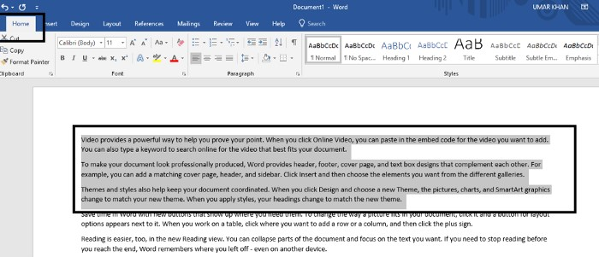

Go to paragraph dialog box and click on any first three options u wish to be selected.

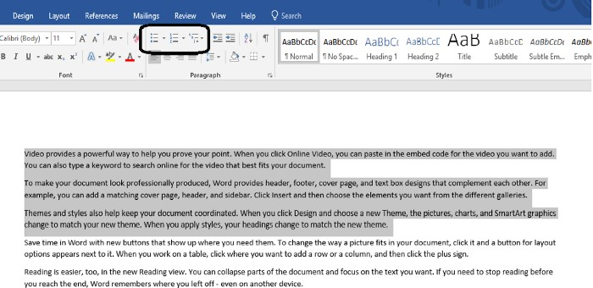

That’s it you are done.

**2.Indenting:**

Same procedure is for indenting as well.

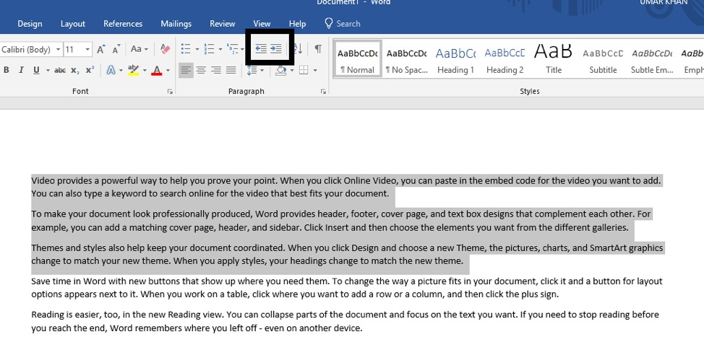

Select paragraphs

Then click on the indenting options i’e left or right in that direction you want to indent the text.

**3.Aligning:**

Select the content or text to be aligned.

Alignment provides four options

* Left
* Right
* Center
* And justify

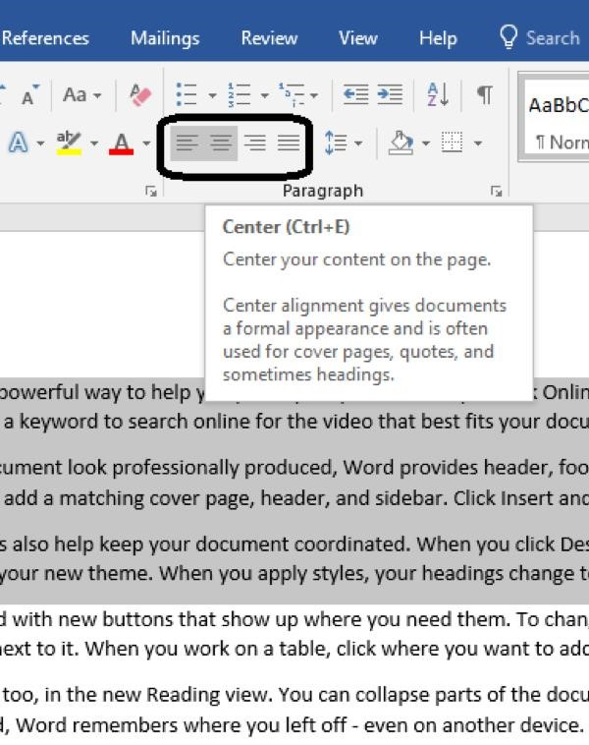

Click on any among the four it will be done.

**4.Shading:**

Select the passages or paragraphs as we did before.

Then go to shading option and click on it.

Select the color as per requirement say blue.

Click on it. You are done.

The selected text will be highlighted in blue.

**STYLES DIALOG BOX:**

To apply a style:

1. Select the text you want to format, or place your cursor at the beginning of the line.

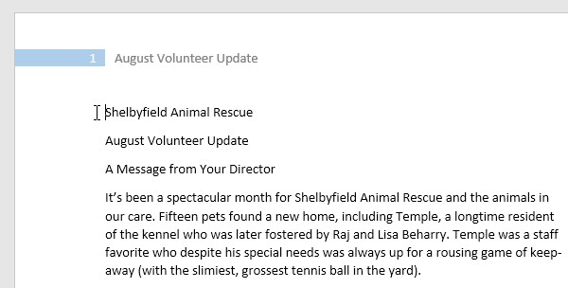

1. In the Styles group on the Home tab, click the More drop-down arrow.

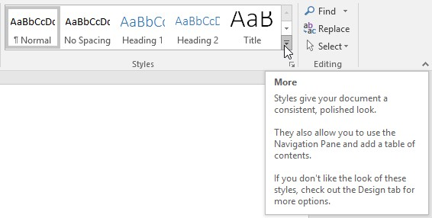

Select the desired style from the drop-down menu.

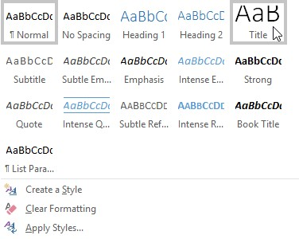

1. The text will appear in the selected style.



With the uses of style dialog box we can give heading to important topic or title of topic. There are different format of heading so with these format we can change the heading style of or title or important info.

**EDITING DIALOG BOX:**

Editing box is used for find and replace text in document.

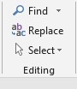

* 1. Click on find option and search for word which you want to find.
  2. For example I want to search “text” in document.

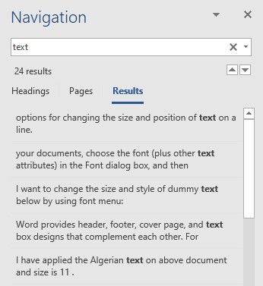

* 1. This will find the text and give result us for our searching.

**Replace:**

* + 1. Click on replace option for replacing word with another word.
    2. For example, I want to replace text word with message, it is shown in figure below there.

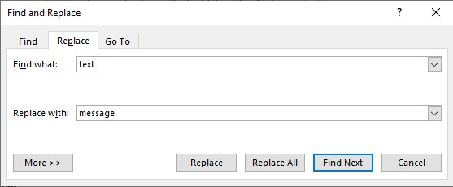

And then click on find next option to complete the steps.

# WEEK 3 (15-3-2021)

**National University of Modern Languages Sector H-9, Islamabad, Pakistan.**



**Department of Software Engineering**

**Course Title: Introduction to Information & Computer Technology**

**Student Name: Hamza Mehmood**

**Roll Number: SP-21-110**

**Lab Number: WEEK 1-12 Date: 1 March to 3 June**

**Lab Assessment Rubrics**

**Method:** Lab report and instructor observation during Lab Session **Outcome Assessed:**

1. Ability to analyze and design solutions to conduct experiments (Psychomotor).
2. Ability to perform in a team (Affective).
3. Ability to apply and comprehend modern engineering tools to develop skills for engineering knowledge and being able to design report and documentation (Psychomotor).

|  |  |  |  |  |
| --- | --- | --- | --- | --- |
| **Performance** | **Exceeds Expectation (4-5)** | **Meets Expectation (2-3)** | **Does not meet Expectation (1)** | **Marks** |
| 1. Realization of  Experiment [c] | Chooses the required yet relevant equipment to perform the experiment establishes setup diagrams of equipment connection or wiring. | Effective guidance is required to choose relevant tools for the experiment and also to develop well connected wiring diagram. | Fails to select the required equipment’s/ tools to perform the experiment or wiring diagram seriously lack clarity or appear ambiguous. |  |
| 2. Teamwork [b] | An active cooperation develops among group members to support the execution of the experiment. | Effectively cooperates with the group members  to perform the experiment. | Negatively affects the other group members and creates hindrance in successful performance or completion of experiment. |  |
| 3. Conducting Experiment [a] | A careful selection of equipment, wiring is done under supervision of instructor for effective operation and task completion. | Carefully examines the  equipment, wiring of all components and calibrate experiments with very few errors. | Incapable of calibrating the suitable equipment and wiring with inaccurate equipment operation. |  |
| 4. Laboratory  Safety Rules [a] | Safety rules and procedures are carefully observed during the experiment. | Scrutiny observes the prescribed safety measures with very minor deviation. | Does not observe the safety rules during experiments. |  |
| 5. Data Collection  [a] | Data collection is carefully planned to achieve experimental objective. | Data collection is carefully planned to get experimental objectives with very minor mistakes. | Incapable of planning the data collection to acquire the experimental objective or the collected data is inappropriate or incomplete. |  |
| 6. Report writing  [c] | Properly written with all results. | Writing report with minor error. | Incomplete Lab report |  |

**Total Marks Obtained:**

**Instructor’s Signature:**

**INSERT TAB:**

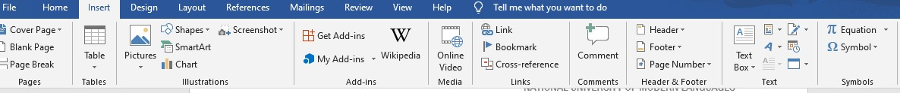

The Insert tab contains various items that you may want to insert into a document. These items include such things as tables, word art, hyperlinks, symbols, charts, signature line, date & time, shapes, header, footer, text boxes, links, boxes, equations and so on.

Pages:

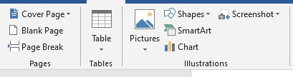

1. From the insert dialog box first we can insert cover page in start of document by clicking on cover page.

# Insert a blank page

To put a blank page into your Word document, place the cursor where you want the new page to begin and then click **Insert** > **Blank Page**. The blank page opens, ready for whatever you want to add.

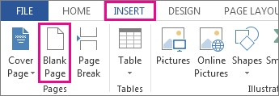

Another option when you need a little space is to insert a page break. The difference is that **Insert** > **Blank Page** puts an entire blank page into your document, and **Insert** > **Page Break** doesn’t. Instead, it pushes whatever comes after the break to the top of the next page.

Break page:



1. Page break option is used for to break the page to next page.
2. When you click on the page beak option it provides another page and jumped to next page.

**Tables:**



1. Tables dialog box is used to insert table in document.
2. To insert table then click on table option that appears in a table dialog box.
3. Then choose how many rows and columns you want to insert in table.
4. For example I want to insert 3 columns and 5 rows then:

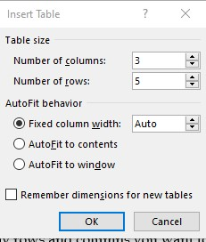

|  |  |  |
| --- | --- | --- |
| Name | Roll no | Department |
| Irfan | 2433 | CS |
| Uzair | 2447 | CS |
| Zohaib | 2444 | CS |
| Hassan | 2442 | CS |

1. For example I have created the table of 3 column and 5 rows.

**Illustrations:**

In addition to inserting and formatting text into your document, Word 2013 also allows you to insert text boxes, lines, shapes, images, ClipArt, and WordArt, through its image and drawing features. In this section, we will cover the diversity of these illustration functions in Word, as well as how to use them most effectively.

The first step to inserting pictures or drawings in Word is accessing the **Illustrations** icon group in the ribbon menu.

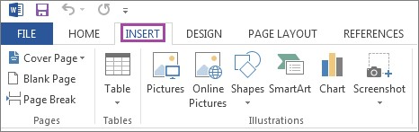

**Adding Pictures:**

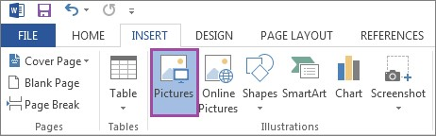

**1.** To insert a picture saved on your hard disk, first select the **Pictures** icon from the ribbon men.

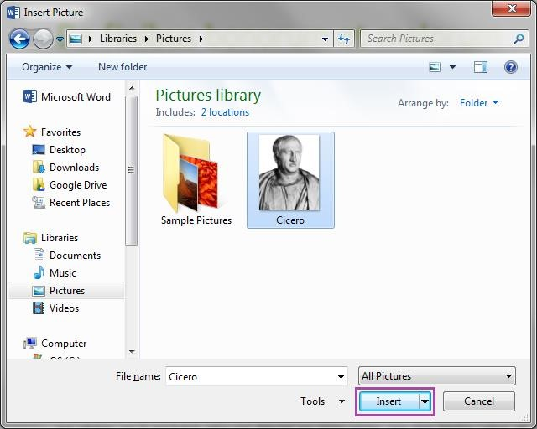

A new window will appear, prompting you to indicate where on the hard disk the picture you want to insert is located. Once you have located the picture, click on the **Insert** button.

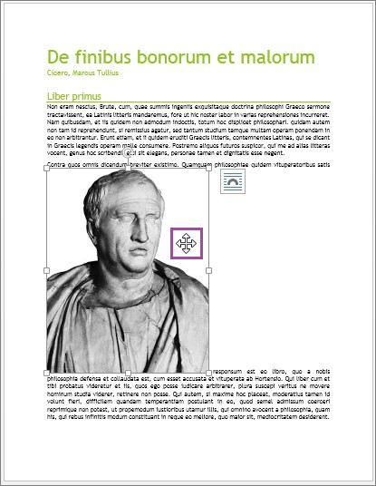

**2.** Once the picture has been inserted, move the cursor anywhere over it, clicking and dragging to move it to where you want it on the page.

## Inserting ClipArt

If your network or internet connection is active, you can insert ClipArt from Microsoft's online database.

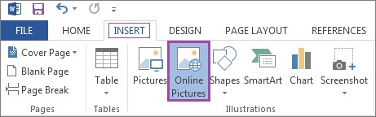

1. To insert ClipArt, click on the **INSERT** tab, and select **Online Pictures**.

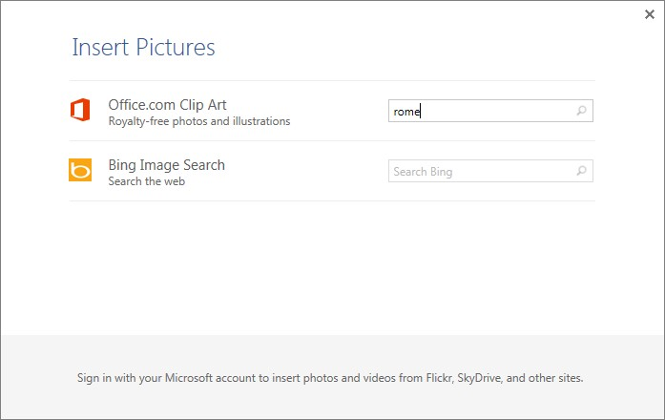

1. In the dialog box, type in a subject in the **Office.com Clip Art** search field, and press **Enter.**

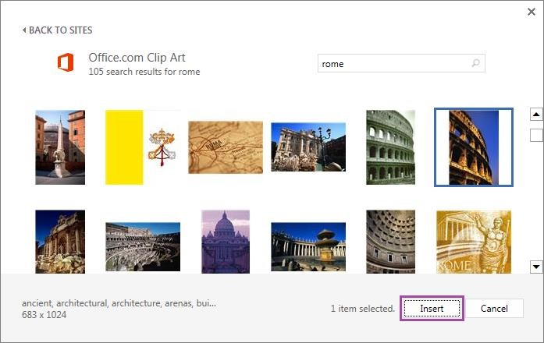

1. Select the ClipArt image you want from the list of results that appear, and click **Insert** to add it to your document. You can move, re-size, format, or change text wrapping using the same method as pictures added from your hard drive.

### Inserting Shapes

1. To insert a shape, click on the **INSERT** tab. Clicking on **Shapes**, select the desired shape from the drop-down menu. Because this option is used quite frequently, we will select **multiple shapes**under **Basic Shapes**, for the purpose of this tutorial.

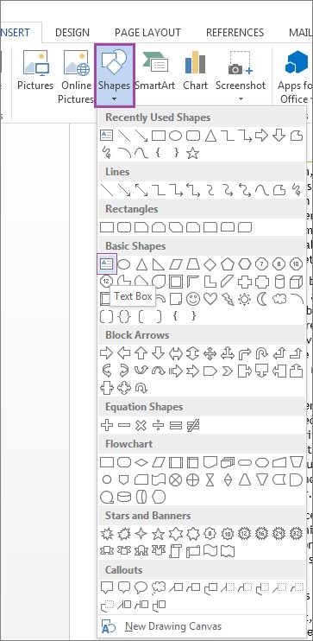

1. For we want to select triangle, arrow and rectangular shapes for trial.

MULTIPLE SHAPES

### SmartArt

In addition to the Text Box feature, Word also includes a feature called **SmartArt**, which allows you to represent ideas in diagram format.

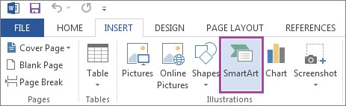

1. To insert SmartArt, click on the **INSERT** tab, and select **SmartArt** under the **Illustrations** icon group on the ribbon menu.

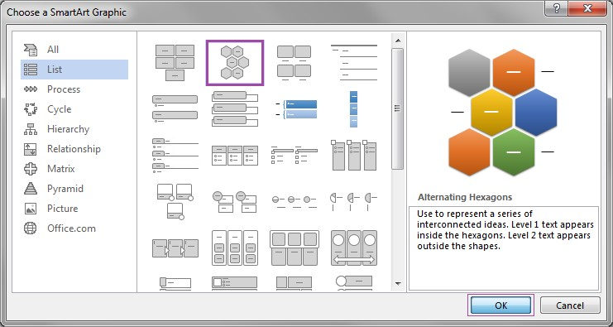

1. A window will appear, prompting you to pick the kind of SmartArt graphic you would like to use. After selecting one from among the many options available, click **OK**.

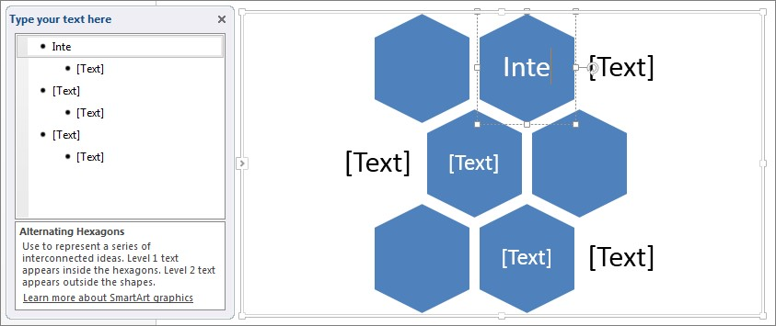

1. Format the text of the SmartArt graphic either by clicking on the text, or using the outline to the left of the graphic.
2. For example we want to add some different smart art so by following above given steps;

Here we have created the cycle smart art .

**Charts:**

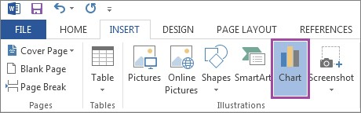

1. To insert a chart, click on the **INSERT** tab, selecting **Chart** under the **Illustrations** icon group on the ribbon menu.

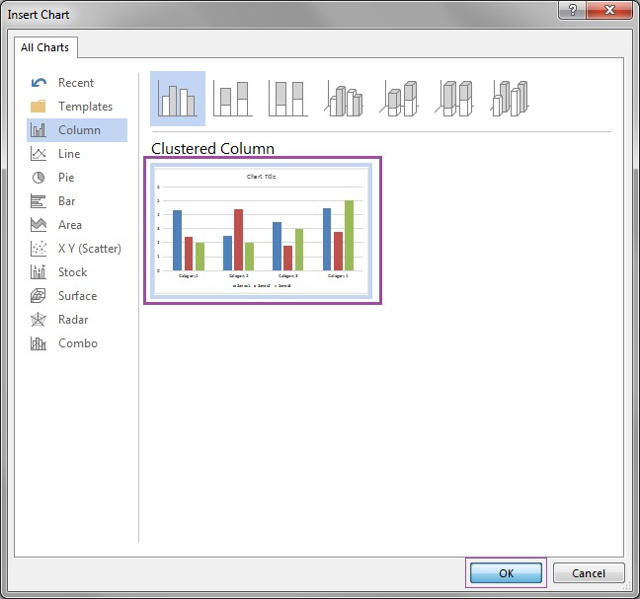

1. Select what kind of chart you wish to insert, and then click **OK**.

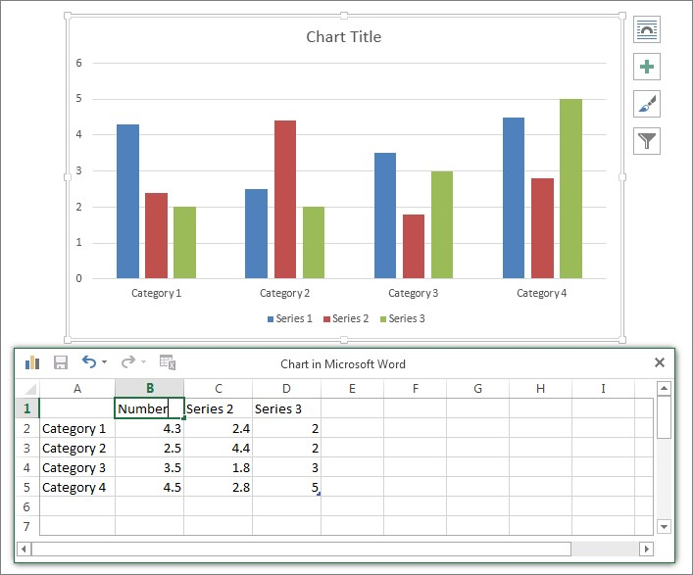

1. Once the chart has been inserted, you can use the Excel popup window to edit the different fields. To format anything on the chart, simply click on what you would like to change. You may also use the ribbon menu. If you would like move or re-size your chart, or to change the way the surrounding text wraps around it

0

1

2

3

4

5

6

kpk

ict

punjab

Category 4

population chart

Series 1

Series 2

Series 3

Here in above I have inserted the chart of population for demo purpose.

**Screenshots**

A feature in Word is the ability to insert screenshots into your document, using the program rather than simply the print screen function of Windows.

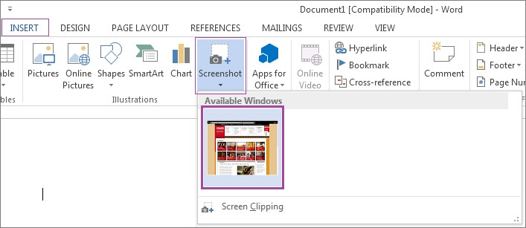

To insert a screenshot into your document, click on the **INSERT** tab, selecting **Screenshot** under the **Illustrations** icon group on the ribbon menu. A drop-down menu will appear, showing you screenshots of all your open windows. To select one, click on it. Once it is inserted, you can further format it. If you would like move or re-size the screenshot, or to change the way the text wraps around it.

## WEEK 4 (22-3-2021)

**National University of Modern Languages Sector H-9, Islamabad, Pakistan.**



**Department of Software Engineering**

**Course Title: Introduction to Information & Computer Technology**

**Student Name: Hamza Mehmood**

**Roll Number: SP-21-110**

**Lab Number: WEEK 1-12 Date: 1 March to 3 June**

**Lab Assessment Rubrics**

**Method:** Lab report and instructor observation during Lab Session **Outcome Assessed:**

1. Ability to analyze and design solutions to conduct experiments (Psychomotor).
2. Ability to perform in a team (Affective).
3. Ability to apply and comprehend modern engineering tools to develop skills for engineering knowledge and being able to design report and documentation (Psychomotor).

|  |  |  |  |  |
| --- | --- | --- | --- | --- |
| **Performance** | **Exceeds Expectation (4-5)** | **Meets Expectation (2-3)** | **Does not meet Expectation (1)** | **Marks** |
| 1. Realization of  Experiment [c] | Chooses the required yet relevant equipment to perform the experiment establishes setup diagrams of equipment connection or wiring. | Effective guidance is required to choose relevant tools for the experiment and also to develop well connected wiring diagram. | Fails to select the required equipments/ tools to perform the experiment or wiring diagram seriously lack clarity or appear ambiguous. |  |
| 2. Teamwork [b] | An active cooperation develops among group members to support the execution of the experiment. | Effectively cooperates with the group members  to perform the experiment. | Negatively affects the other group members and creates hindrance in successful performance or completion of experiment. |  |
| 3. Conducting Experiment [a] | A careful selection of equipment, wiring is done under supervision of instructor for effective operation and task completion. | Carefully examines the  equipment, wiring of all components and calibrate experiments with very few errors. | Incapable of calibrating the suitable equipment and wiring with inaccurate equipment operation. |  |
| 4. Laboratory  Safety Rules [a] | Safety rules and procedures are carefully observed during the experiment. | Scrutiny observes the prescribed safety measures with very minor deviation. | Does not observe the safety rules during experiments. |  |
| 5. Data Collection  [a] | Data collection is carefully planned to achieve experimental objective. | Data collection is carefully planned to get experimental objectives with very minor mistakes. | Incapable of planning the data collection to acquire the experimental objective or the collected data is inappropriate or incomplete. |  |
| 6. Report writing  [c] | Properly written with all results. | Writing report with minor error. | Incomplete Lab report |  |

**Total Marks Obtained:**

**Instructor’s Signature:**

### Header & Footer

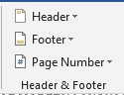

**Header** - Drop-Down. This displays a gallery of the built-in headers. The drop-down also contains the commands Edit Header, Remove Header and Save Selection to Header Gallery. Also appears on the Header and Footer Tools - Design contextual tab. **Footer** - Drop-Down. This displays the gallery of built-in footers. The drop-down also contains the commands Edit Footer, Remove Footer and Save Selection to Footer Gallery. Also appears on the Header and Footer Tools - Design contextual tab.

**Page Number** - Drop-Down. The drop-down contains the commands: Top of Page,

Bottom of Page, Page Margins, Current Position, Format Page Numbers and Remove Page Numbers. The first four commands all display galleries of built-in page number options and allow you save your own to the gallery. The Format Page Numbers command displays the familiar "Page Number Format" dialog box.

1. Click on **either header or footer** drop-down menu in the **Header & Footer section.**
2. A Header or Footer drop-down menu will display on the screen with a list of built-in Header or Footer options. Select your desired option from the Built-in list.

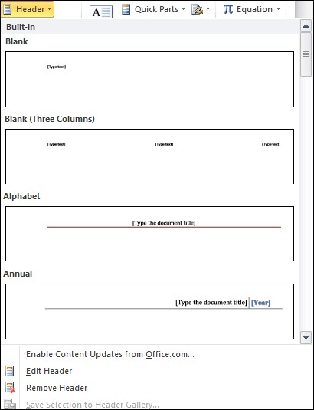

Type your desired information into the header or footer section.

Header is inserted into the top of pages while footer is inserted at the bottom of pages.

**TEXT :**

**TEXT BOX:**

* Select the Insert tab
* Locate the Text group
* Click the Text Box button
* It displays Built-In text box menu and an option to draw table
* With a left click select the desired text box format from the menu

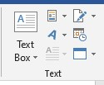

A drop-down menu will appear. Select Draw Text Box.

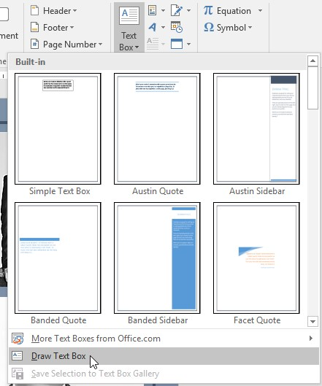

Click and drag anywhere on the document to create the text box.

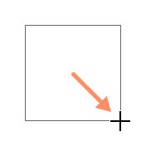

The insertion point will appear inside the text box. You can now type to create text inside the text box.

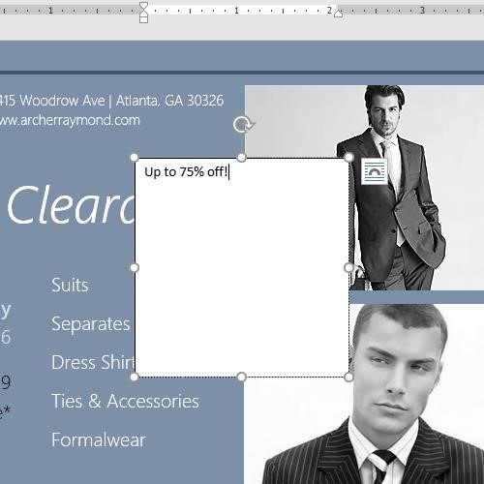

#### WordArt

To insert decorative text into the document, click this button. A gallery of different styles of WordArt will display. Click the desired format to create the WordArt image.

**SIGNATURE:**

**SIGNATURE**

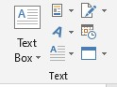

This button is used to insert a digital signature line into a document that indicates who must sign the document. A Digital ID must be obtained before this feature can be used.

Date and Time:



To insert the date and time into a document, click this button. The dialog box that appears displays several date and time formats. This option is used to insert date and time into the document.

***Symbols:***

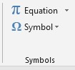

Symbols:

Click this button to insert a symbol such as a copyright or trademark into the document. For example, (₧↨±©®™).

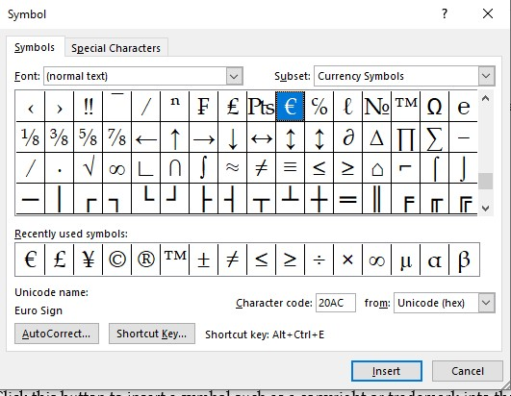

To insert any symbol first click on symbol and then click on insert option as shown in figure above.

Equation:

This button is used to insert a mathematical equation into a document. The equation tools ribbon will appear when the button is clicked. This ribbon is used to create the equation. A list of common equations is also available.

List of equation is:

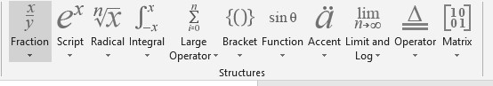

Comments:

A comment in a Word document is useful when needing to make note of something that requires attention or needs fixed, or provide additional information to others reading the document.

1. On the Insert tab, click the **Comment** option in the Comments group.
2. The new comment is added to the document. On the right side of the document, the comment is visible. Click in the comment to enter the desired

text

.

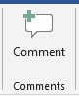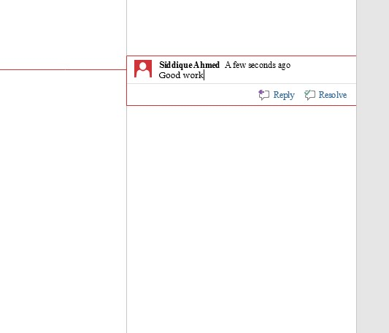

here I inserted the comment in my document for any text which I want.

Edit a document:

1. In the Microsoft Word document, find the comment you want to edit.
2. The comment should be visible on the right side of the document. **Click in the comment** and edit the text for that comment.

#### Delete a comment

To delete a comment in a Microsoft Word document, follow the steps below.

1. In the Microsoft Word document, find the comment you want to delete.
2. Using your mouse, place the text cursor over the comment on the right side of the document.
3. [Right-click](https://www.computerhope.com/jargon/r/righclic.htm) with your mouse and select the **Delete Comment** option in the popup menu that appears.

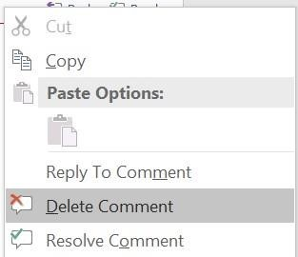

#### Design Tab

##### Document Formatting



**Themes** - The drop-down contains the commands: Built-in, More Themes on Microsoft Office Online, Browse for Themes and Save Current Theme. The built-in themes are:

Office, Apex, Aspect, Civic, Concourse, Equity, Flow, Foundry, Median, Metro, Module, Opulent, Oriel, Origin, Paper, Solstice, Technic, Trek, Urban and Verve. Tooltip indicates the current theme. The default theme is "Office". Tooltip indicates the current theme.

Quick Access to more themes saved down on Microsoft Office Online. Default theme is "Office". Changes the overall design of the entire document in colours, fonts and effects. This drop-down has an additional command not found in Excel or PowerPoint which is "Reset to Theme from Template".

**Style Set** - Change the look of your document by choosing a new style set. Style sets change the font and paragraph properties of your entire document.

**Colors** - Drop-Down. Displays a list of all the available colors and lets you change the color component of the active theme.

**Fonts** - Drop-Down. Displays a list of all the available fonts and lets you change the font component of the active theme.

**Paragraph Spacing** -. Drop-Down. Quickly change the line and paragraph spacing in your document. The drop-down contains the commands: No Paragraph Space, Compact, Tight, Open, Relaxed, Double, Custom Paragraph Spacing.

**Effects** -. Drop-Down. Displays a list of all the available effects and lets you change the effect component of the active theme. The drop-down contains the commands: Office, Apex, Aspect, Civic, Concourse, Equity, Flow, Foundry, Median, Metro, Module, Opulent, Oriel, Origin, Paper, Solstice, Technic, Trek, Urban and Verve.

**Set As Default** - Use the current look for all new documents.

##### Page Background

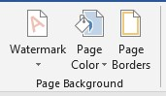

**Watermark** - Drop-Down. The drop-down contains the commands: Custom Watermark, Remove Watermark and Save Selection to Watermark Gallery.

**Page Color** - Drop-Down. Lets you change the background colour of the page. Displays the full theme colour palette.

**Page Borders** - Displays the "Border and Shading" dialog box. LAYOUT

PAGE SETUP:

A margin is the space between the text and the edge of your document. By default, a new document's margins are set to Normal, which means it has a one-inch space between the text and each edge.

Depending on your needs, Word allows you to change your document's margin size.

To format page margins:

* 1. Select the Layout tab, then click the Margins command.

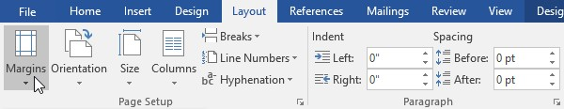

* 1. A drop-down menu will appear. Click the **predefined margin size** you want.

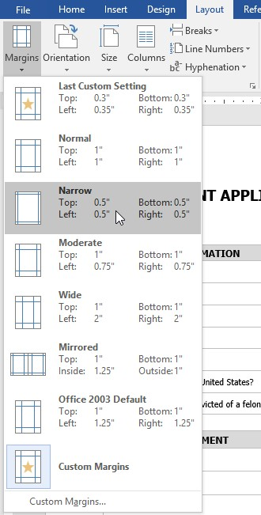

* 1. The margins of the document will be changed.

To change page orientation:

* + 1. Select the **Layout** tab.
    2. Click the **Orientation** command in the Page Setup group.

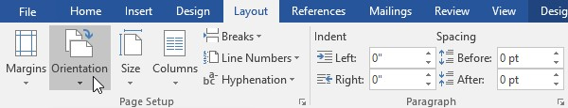

* + 1. A drop-down menu will appear. Click either **Portrait** or **Landscape** to change the page orientation.

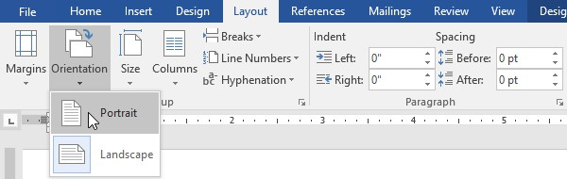

* + 1. The page orientation of the document will be changed.

Page size:

By default, the page size of a new document is 8.5 inches by 11 inches. Depending on your project, you may need to adjust your document's page size.

To change the size of page:

1. Select the Layout tab, then click the Size command.
2. A drop-down menu will appear. The current page size is highlighted. Click the desired predefined page size.

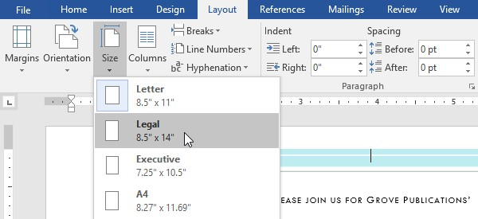

1. The size of page will be changed.

Column:

Column option is used to insert column like in newspaper and in other magazines.

1. Select the text you want to format.

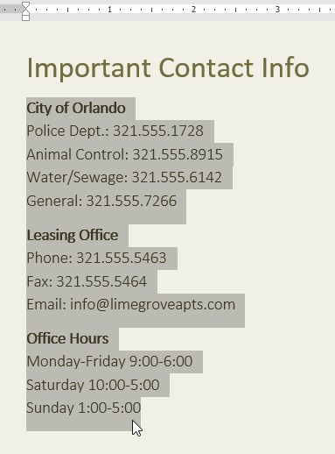

1. Select the **Layout** tab, then click the **Columns** command. A drop-down menu will appear.
2. Select the number of columns you want to create.

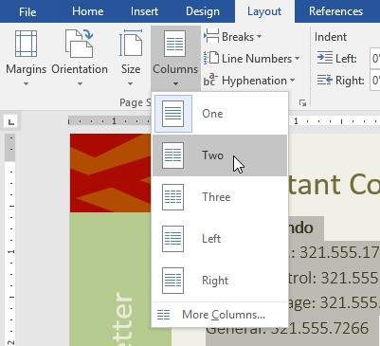

1. The text will format in columns.

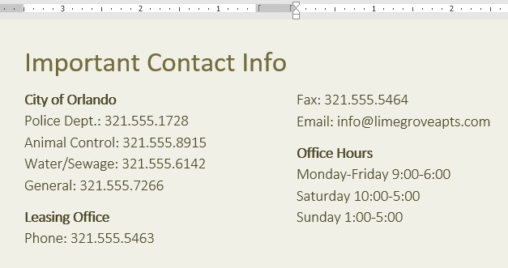



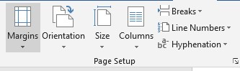

Break option is used to break the page and jumped to next page.

And line numbers option is used to insert line numbers in your document and is useful for to count lines.

Paragraph:

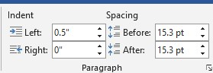

**Indent:**

Indent option is used for to move your paragraph to left or right from its original position. It can be moved to left or right as you want to change.

**Spacing:**

Spacing option is used to insert space between your paragraph when we use before option it makes spacing between two paragraphs equal and if we use after option then it repels two paragraphs against each other.

**References**

**Table of contents:**



1. In this tab first of all there is table of contents option it is used for insert table of contents in document e.g in first page of every book there is also table of content which we can make in MS word.

**Table of Contents** - Drop-Down. Provide an overview of your document by adding a table of contents. The drop-down contains the commands: Built-in, Insert Table of Contents and Save Selection to Table of Contents Gallery. **Add Text** - Drop-Down. The drop-down contains the commands: Do Not Show in Table of Contents, Level 1, Level 2 and Level 3.

**Update Table** - Updates the table of contents so that all the entries refer to the correct page numbers.

##### Create the table of contents

1. Put your cursor where you want to add the table of contents.
2. Go to **References** > **Table of Contents**. and choose an automatic style.

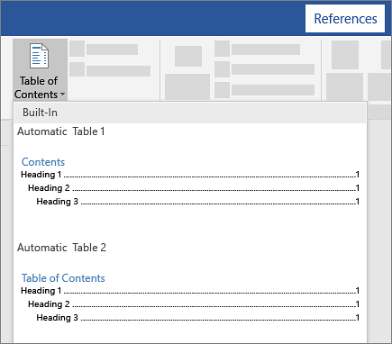

1. If you make changes to your document that affect the table of contents, update the table of contents by right-clicking the table of contents and choosing **Update Field**.

###### To update your table of contents manually, see [Update a table of contents.](https://support.microsoft.com/en-us/office/update-a-table-of-contents-6c727329-d8fd-44fe-83b7-fa7fe3d8ac7a) Add a Table of Contents

Regardless of the size of your document, using a table of contents can direct the reader to exactly where they need to be. In addition to making the document more readerfriendly, a table of contents also makes it easier for the author to go back and add or remove content if necessary.

By default, Word generates a table of contents using the first three built-in heading styles (Heading 1, Heading 2, and Heading 3). To apply heading styles, select the particular style from the “Home” tab. If you’re not happy with the types of heading styles available, you can [change the default heading style.](https://www.howtogeek.com/399978/how-to-change-heading-styles-in-ms-word/)

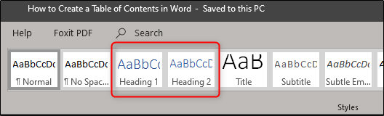

You can manage this in two different ways. You can either apply the heading styles to each section after you’ve finished the document, or you can add them as you go.

Once you’ve applied your heading styles, it’s time to insert your table of contents. The first thing you need to do is put the cursor where you want the table of contents to appear. Once ready, head over to the “References” tab and select “Table of Contents.”

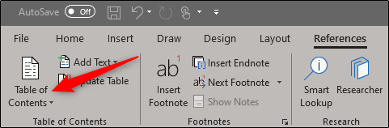

A drop-down menu will appear. Here, you can choose between the three different builtin tables.

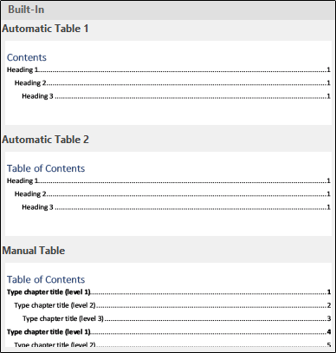

The only difference between Automatic Table 1 and 2 is the title, which is “Contents” and “Table of Contents,” respectively. Selecting either Automatic Table 1 or 2 will create the table of contents using the names of the headings.

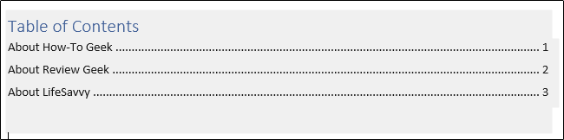

If you chose the “Manual Table” option from the “Table of Contents” drop-down menu, then it will insert a template for you that you will need to edit yourself.

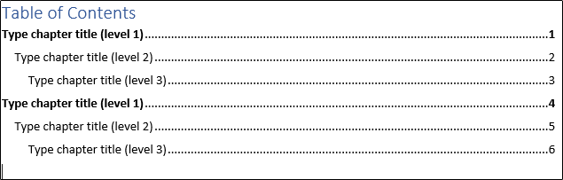

You may notice in this table of contents that there are sub-levels. Each level represents a heading style in your document. So if you use the automatic table and you want sublevels in your ToC, you will need to use heading 1 for level 1, heading 2 for level 2, and heading 3 for level 3.

If you want your table of contents to go deeper than the top three heading styles, you can do that, too. On the dropdown menu when you click the “Table of Contents” button,

choose the “Custom Table of Contents” option.

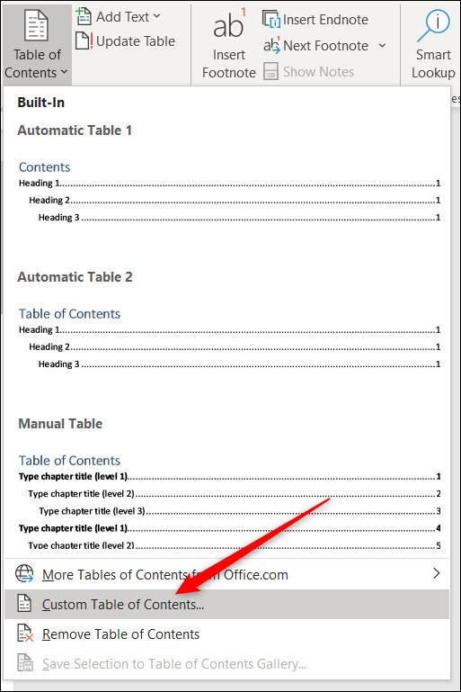

In the Table of Contents window that opens, click the “Options” button.

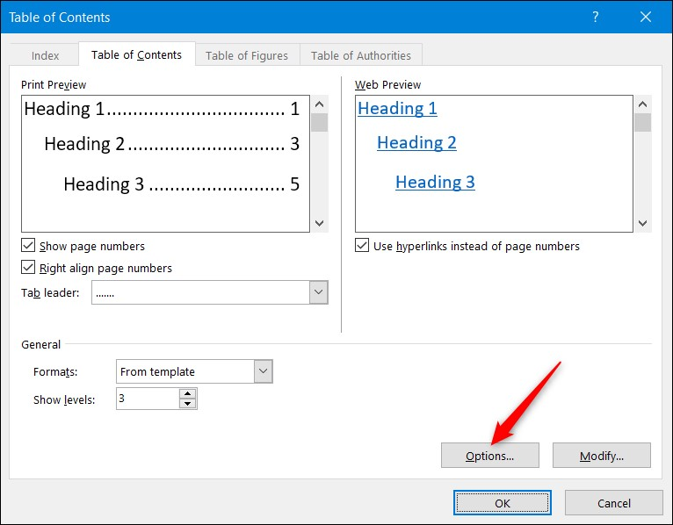

In the Table of Contents Options window, next to each available style you want to use (these are Word’s built-in styles starting with Heading 4), type the TOC level you wish to use. Click “OK” when you’re done.

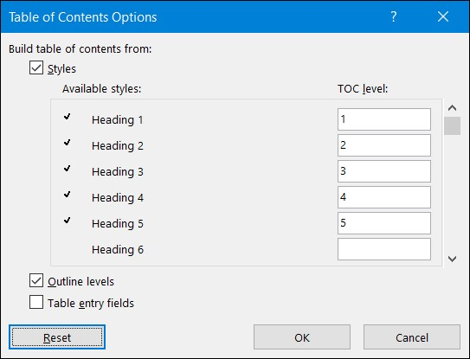

##### Updating the Table of Contents

If you ever need to add or remove a section from your document, you can easily update the table of contents to reflect those changes. To update your table of contents, select it, click “Update Table” on the pop-up menu that appears, and then choose whether you want to update only the page numbers or the entire table. Click “OK” to apply the changes.

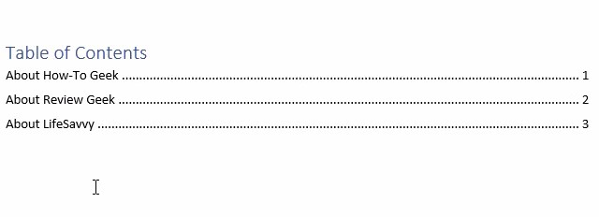

Your table of contents will now be updated.

##### Removing the Table of Contents

Removing the table of contents is simple. All you need to do is select it and then click the arrow on the menu that appears.

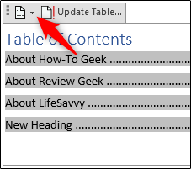

At the bottom of the drop-down menu, select “Remove Table of Contents.”

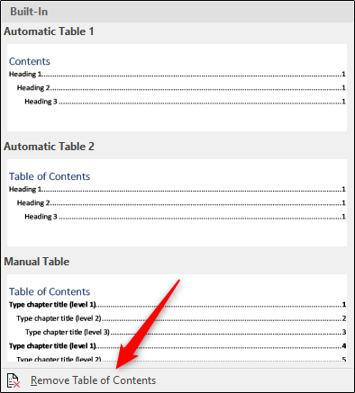

Your table of contents will now be removed from your document.

###### **Footnotes**

You can quickly display the "Footnote and Endnote" dialog box by clicking on the dialog box launcher in the bottom right corner of this group.

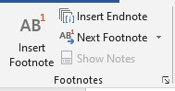

**Insert Footnote** - (Alt + Ctrl + F). Inserts a footnote at the current position.

Footnotes are automatically renumbered as you move text around the document.

**Insert Endnote** - (Alt + Ctrl + D). Inserts an endnote at the end of the document.

End notes are always placed at the end of a document.

**Next Footnote** - Button with Drop-Down. The button moves to the next

footnote. The drop-down provides the commands Next Footnote, Previous Footnote, Next Endnote and Previous Endnote.

**Show Notes** - Shows where footnotes and endnotes are located

Citations & Bibliography

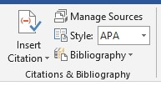

**Insert Citation** - Drop-Down. The drop-down contains the commands: Add New Source, Add New Placeholder and Search Libraries.

**Manage Sources** - Displays a list of all the sources cited in the active document.

**Style** - Choose the style of citation to use in the document.

**Bibliography** - Drop-Down. The drop-down contains the commands: Insert Bibliography and Save Selection to Bibliography Gallery.

###### **Caption**

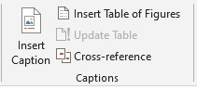

**Insert Caption** - Insert a caption below a picture or graphic to provide a short description.

**Insert Table of Figures** - Add a list of captioned objects and their page numbers. **Update Table** - Updates the table of figures to include all of the entries in the document.

**Cross-reference** - Displays the "Cross-reference" dialog box allowing you to insert cross-referencing into your document, for example: turn to page 3 or please refer to page 12. Cross references are inserted as hyperlinks.

The **Insert Caption** feature in Word does most of the heavy lifting for you, when you want to add a caption to a picture. For other Office apps, it’s a little trickier and involves [adding a text box](https://support.microsoft.com/en-us/office/add-copy-or-delete-a-text-box-4d968daa-5c86-48f2-88fa-b65871966017) and then [grouping the text box and picture.](https://support.microsoft.com/en-us/office/group-or-ungroup-shapes-pictures-or-other-objects-a7374c35-20fe-4e0a-9637-7de7d844724b) And if you have multiple pictures in a series, you’ll have to manually track and increase the numbers.

### Word

1. Click the picture you want to add a caption to.
2. Click **References** > **Insert Caption**.

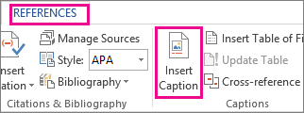

1. To use the default label (Figure), type your caption in the **Caption** box.

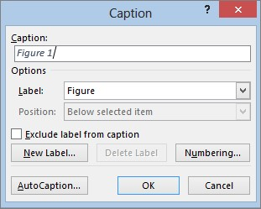

#### Index

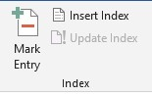

**Mark Entry** - (Alt + Shift + X). Marks the currently selected text so it will appear in the index of the document.

**Insert Index** - Add an index listing key words and page numbers they appear on.

**Update Index** - Updates the index table.

Table of authorities:

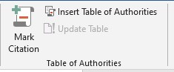

**Mark Citation** - (Alt + Shift + I). Adds the currently selected text so it will appear in the table of authority.

**Insert Table of Authorities** - Inserts a table of authorities for cases, statutes and other authorities in the document.

**Update Table** - Updates the table of authorities to include all the citations in the document.

#### Mailings Tab

This tab contains everything needed to complete a successful mail merge

##### Create

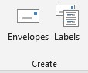

**Envelopes** - Lets you create and print envelopes. **Labels** - Lets you create and print labels.

##### Start Mail Merge

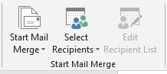

**Start Mail Merge** - Drop-Down. The drop-down contains the commands: Letters, E-mail

Messages, Envelopes, Labels, Directory, Normal Word Document and Step-by-Step Mail

Merge Wizard. Creates a from letter which you intend to email or print multiple times sending each copy to a different recipient. Displays the "New Address List" dialog box. **Select Recipients** - Drop-Down. The 3 options are from step 3 of the wizard. The dropdown contains the commands: Type New List, Use Existing List and Select from Outlook Contacts. Type New List displays the "New Address List" dialog box. You will have to save this list as a Microsoft Office Address List (.mdb).

**Edit Recipient List** - Displays the "Mail Merge Recipients" dialog box allowing you to change or filter the list of recipients.

##### Write & Insert Fields

These commands are only available when you are in a mail merge document.

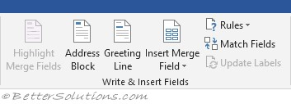

**Highlight Merge Fields** - Highlights all the fields in the active document that have been inserted. This makes is easy to see what will be replaced.

**Address Block** - Displays the "Insert Address Block" dialog box. This allows you to customize how the address will be inserted.

**Greeting Line** - Displays the "Insert Greeting Line" dialog box. Lets you add a greeting line to your document.

**Insert Merge Field** - Button with Drop-Down. The button displays the "Insert Merge Field" dialog box. The drop-down allows you to quickly insert a merge field just by clicking on it in the list and contains the commands: Title, First_Name, Last_Name, Company_Name, Address_Line_a, Address_Line_2, City, State, Zip_Code, Country_or_Region, Home_Phone, Work_Phone, Email_Address.

**Rules** - Drop-Down. Lets you add decision making rules to the mail merge. The dropdown contains the commands: Ask, Fill-in, If-Then-Else, Merge Record, Merge Sequence, Next Record, Next Record If, Set Bookmark, Skip Record If.

**Match Fields** - Displays the "Match Fields" dialog box allowing you to match the required fields with the recipients list.

**Update Labels** - Only enabled when creating labels. Updates all the labels in the document to be consistent with the first label.

###### Preview Results

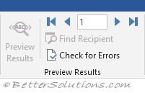

**Preview Results** - This is disabled when there are no fields in your document. Toggles the merged fields in your document with actual data from your recipient list.

**First Record** - View the first record in the recipient list.

**Previous Record** - View the previous record in the recipient list.

**Go to Record** - View a specific record in the recipient list.

**Next Record** - View the next record in the recipient list.

**Last Record** - View the last record in the recipient list.

**Find Recipient** - Displays the "Find Entry" dialog box to search for a particular text entry.

**Auto Check for Errors** - (Alt + Shift + K). Displays the "Checking and Reporting Errors" dialog box. This allows you to simulate the mail merge and to specify how to handle any errors that occur during mail merge. You can even simulate the merge and report errors in a new document.

###### Finish



**Finish & Merge** - Drop-Down. The drop-down contains the commands: Edit Individual Documents, Print Documents and Send E-mail Messages.

**National University of Modern Languages**

Introduction to MS Power Point

# Week 5

**National University of Modern Languages Sector H-9, Islamabad, Pakistan.**



**Department of Software Engineering**

**Course Title: Introduction to Information & Computer Technology**

**Student Name: Hamza Mehmood**

**Roll Number: SP-21-110**

**Lab Number: WEEK 1-12 Date: 1 March to 3 June**

**Lab Assessment Rubrics**

**Method:** Lab report and instructor observation during Lab Session **Outcome Assessed:**

1. Ability to analyze and design solutions to conduct experiments (Psychomotor).
2. Ability to perform in a team (Affective).
3. Ability to apply and comprehend modern engineering tools to develop skills for engineering knowledge and being able to design report and documentation (Psychomotor).

|  |  |  |  |  |
| --- | --- | --- | --- | --- |
| **Performance** | **Exceeds Expectation (4-5)** | **Meets Expectation (2-3)** | **Does not meet Expectation (1)** | **Marks** |
| 1. Realization of  Experiment [c] | Chooses the required yet relevant equipment to perform the experiment establishes setup diagrams of equipment connection or wiring. | Effective guidance is required to choose relevant tools for the experiment and also to develop well connected wiring diagram. | Fails to select the required equipments/ tools to perform the experiment or wiring diagram seriously lack clarity or appear ambiguous. |  |
| 2. Teamwork [b] | An active cooperation develops among group members to support the execution of the experiment. | Effectively cooperates with the group members  to perform the experiment. | Negatively affects the other group members and creates hindrance in successful performance or completion of experiment. |  |
| 3. Conducting Experiment [a] | A careful selection of equipment, wiring is done under supervision of instructor for effective operation and task completion. | Carefully examines the  equipment, wiring of all components and calibrate experiments with very few errors. | Incapable of calibrating the suitable equipment and wiring with inaccurate equipment operation. |  |
| 4. Laboratory  Safety Rules [a] | Safety rules and procedures are carefully observed during the experiment. | Scrutiny observes the prescribed safety measures with very minor deviation. | Does not observe the safety rules during experiments. |  |
| 5. Data Collection  [a] | Data collection is carefully planned to achieve experimental objective. | Data collection is carefully planned to get experimental objectives with very minor mistakes. | Incapable of planning the data collection to acquire the experimental objective or the collected data is inappropriate or incomplete. |  |
| 6. Report writing  [c] | Properly written with all results. | Writing report with minor error. | Incomplete Lab report |  |

**Total Marks Obtained:**

**Instructor’s Signature:**

# 

**INTRODUCTION:**

PowerPoint (PPT) is a powerful, easy-to-use presentation graphics software program which allows you to create professional-looking electronic slide shows. PPT is used to present information in an organized manner to an individual or group.

Home tab

#### Slides

|  |
| --- |
|  |

**New Slide** - Button with Drop-Down. The button inserts a new blank Title and Content Slide. The drop-down contains the slides: Title Slide, Title and Content, Duplicate Selected Slides, Slides from Outline and Reuse Slides.  
**Layout** - Drop-Down. The drop-down contains the commands: Title Slide and Title and Content.  
**Reset** - Reset the position, size and formatting of the slide placeholders to their default settings.  
**Section** – it is used for add different section in slides.

#### Drawing

You can quickly ..

|  |
| --- |
|  |

**Shapes** - gallery  
**Arrange** - Drop-Down. The drop-down contains the commands: Bring to Front, Send to Back, Bring Forward, Send Backward, Group, Ungroup, Regroup, Align, Rotate and Selection Pane.  
**Quick Styles** - Drop-Down. The drop-down contains the commands:  
**Shape Fill** - Button with Drop-Down. The button .. The drop-down contains the commands:  
**Shape Outline** - Button with Drop-Down. The button .. The drop-down contains the commands: Theme Colors, Standard Colors, Recent Colors, No Outline, More Outline Colors, Weight, Dashes and Arrows.  
**Shape Effects** - Drop-Down. The drop-down contains the commands: Preset, Shadow, Reflection, Glow, Soft Edges, Bevel and 3D Rotation.

### Insert Tab

#### Slides

|  |
| --- |
|  |

**New Slide** -it is used for insert new slides in document.

#### Tables

|  |
| --- |
|  |

**Table** - Drop-Down. The drop-down displays the commands: Insert Table, Draw Table and Excel Spreadsheet.

#### Illustrations

|  |
| --- |
|  |

**Shapes** - Drop-Down. Consolidated drop-down list of all the shapes including lines, rectangles, basic shapes, block arrows, equation shapes, flow charts, stars and banners and callouts.  
  
**SmartArt** - Displays the "SmartArt Graphic" dialog box which lets you choose from the following different types of smartart: list, process, cycle, hierarchy, relationship, matrix and pyramid.  
**Chart** - Inserts a Microsoft Graph chart . we already discussed about charts in MS word and it is same as in PowerPoint.

#### Links

|  |
| --- |
|  |

**Zoom** -  
**Link** - Displays the "Insert Hyperlink" dialog box. (Previously called the Hyperlink)  
**Action** - Lets you add an action to the currently selected object. Displays the "Action Settings" dialog box.

## *Audio:*

### **Purpose**

Used to insert a audio clip in a slide

### **Steps and pictures**

* Click the Insert tab.



* Click the Audio icon.

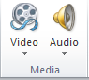

* In the drop-down menu that opens, select the Audio on My PC option.

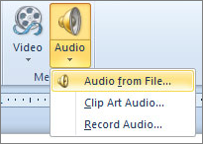

* In the Insert Audio window, find and select the sound file you want to insert into the PowerPoint slide, then click OK.
* After the sound file has been inserted, an icon that looks like a speaker with sound coming out of it appears. You can move the sound icon to another location on the slide.

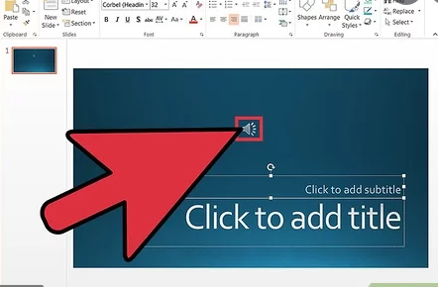

## 

## *Video:*

### **Purpose**

Used to insert a video clip in a slide

### **Steps and pictures**

* Go to the slide in which you want to insert the video.
* Click on the **‘insert’ tab**
* Click on the arrow under **‘video’**.

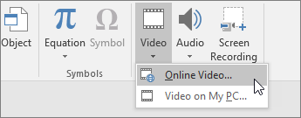

* Click on ‘video on My PC’.

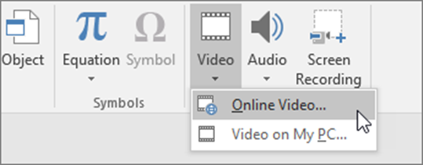

* In the **‘insert video’** box click on the video that you require to embed.
* Tap on **‘insert’.**

## *Slide number:*

### **Purpose**

Used to inset a slide number into the slides

### **Steps with picture**

* On the **Insert** tab, select **Slide Number**.

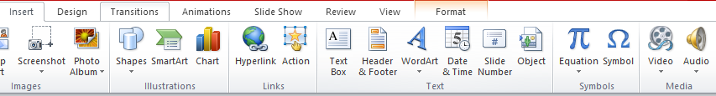

* On the **Slide** tab, check the **Slide number** box. If you don't want a **number** to appear on the title **slide**, also check the Don't show on title **slide** box.

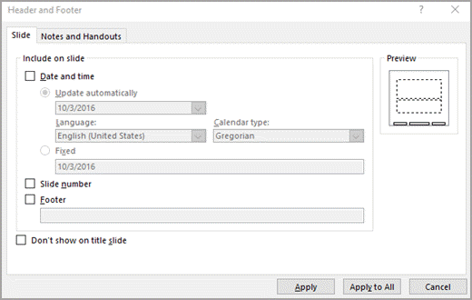

* Select Apply to All

**National University of Modern Languages**

Features of MS Power Point

# Week 6

**National University of Modern Languages Sector H-9, Islamabad, Pakistan.**



**Department of Software Engineering**

**Course Title: Introduction to Information & Computer Technology**

**Student Name: Hamza Mehmood**

**Roll Number: SP-21-110**

**Lab Number: WEEK 1-12 Date: 1 March to 3 June**

**Lab Assessment Rubrics**

**Method:** Lab report and instructor observation during Lab Session **Outcome Assessed:**

1. Ability to analyze and design solutions to conduct experiments (Psychomotor).
2. Ability to perform in a team (Affective).
3. Ability to apply and comprehend modern engineering tools to develop skills for engineering knowledge and being able to design report and documentation (Psychomotor).

|  |  |  |  |  |
| --- | --- | --- | --- | --- |
| **Performance** | **Exceeds Expectation (4-5)** | **Meets Expectation (2-3)** | **Does not meet Expectation (1)** | **Marks** |
| 1. Realization of  Experiment [c] | Chooses the required yet relevant equipment to perform the experiment establishes setup diagrams of equipment connection or wiring. | Effective guidance is required to choose relevant tools for the experiment and also to develop well connected wiring diagram. | Fails to select the required equipments/ tools to perform the experiment or wiring diagram seriously lack clarity or appear ambiguous. |  |
| 2. Teamwork [b] | An active cooperation develops among group members to support the execution of the experiment. | Effectively cooperates with the group members  to perform the experiment. | Negatively affects the other group members and creates hindrance in successful performance or completion of experiment. |  |
| 3. Conducting Experiment [a] | A careful selection of equipment, wiring is done under supervision of instructor for effective operation and task completion. | Carefully examines the  equipment, wiring of all components and calibrate experiments with very few errors. | Incapable of calibrating the suitable equipment and wiring with inaccurate equipment operation. |  |
| 4. Laboratory  Safety Rules [a] | Safety rules and procedures are carefully observed during the experiment. | Scrutiny observes the prescribed safety measures with very minor deviation. | Does not observe the safety rules during experiments. |  |
| 5. Data Collection  [a] | Data collection is carefully planned to achieve experimental objective. | Data collection is carefully planned to get experimental objectives with very minor mistakes. | Incapable of planning the data collection to acquire the experimental objective or the collected data is inappropriate or incomplete. |  |
| 6. Report writing  [c] | Properly written with all results. | Writing report with minor error. | Incomplete Lab report |  |

**Total Marks Obtained:**

**Instructor’s Signature:**

### Design Tab

#### Themes

|  |
| --- |
|  |

**Themes** - gallery  
**Colors** - Drop-Down.  
**Fonts** - Drop-Down.  
**Effects** - Drop-Down.

# Design in PowerPoint

**Themes**

1. Select the **Design** tab.
2. Select one of the **Themes**.
3. Select one of the **Variants**.

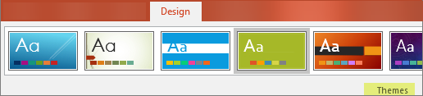

**Use PowerPoint Designer**

1. Insert one or more pictures, a list of items, or a list of dates.
2. The **Designer**panel will open. Select the design you want.

You can also bring up Designer by selecting a picture, and then selecting **Design**> **Design Ideas**.

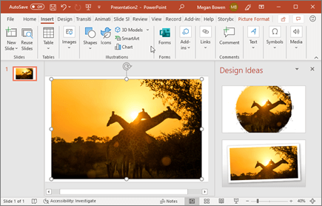

#### Variants

|  |
| --- |
|  |

**Gallery** -

#### Customize

|  |
| --- |
|  |

**Slide Size** -  
**Format Background** -

#### Designer

|  |
| --- |
|  |

**Design Ideas** –

The **Design Ideas** button should be on the right side of your screen, like you see here:

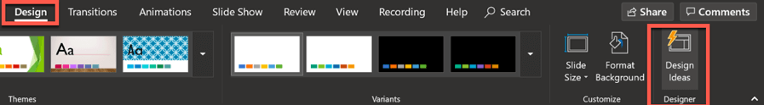

Now, let me give you a quick peek into how this tool works!

Take a look at the screenshots below. I only wrote the word ‘Hello’ on the slide, and look at what the Design Ideas panel on the right side of the screen have come up with!

This is on PowerPoint (Mac):

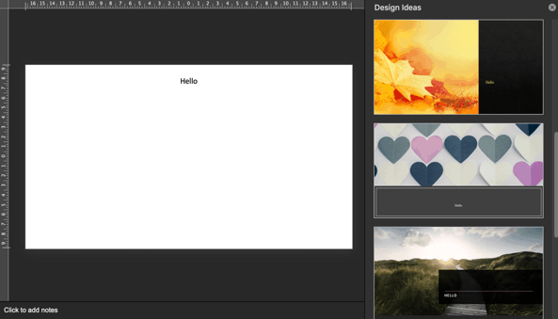

This is on PowerPoint (Windows):

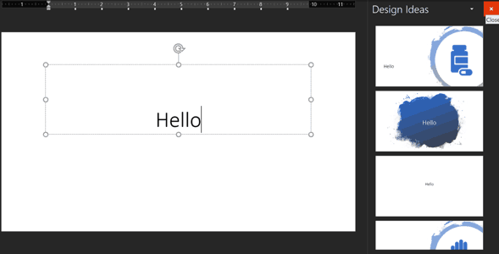

As you can see, the same text (Hello) generated vastly different design ideas. On Mac, the suggestions were visually captivating with beautiful imagery used as background. On Windows, the suggestions were a bit basic to be honest.

This is the beauty of Design Ideas – the suggestions appear to be random. So, if you’re not happy with any of the suggestions, you can give it another try and you’ll get a bunch of new ideas.

So, for the next example, I deleted a couple of characters from the ‘Hello’ text, and then retyped them again. I got the following design ideas next:

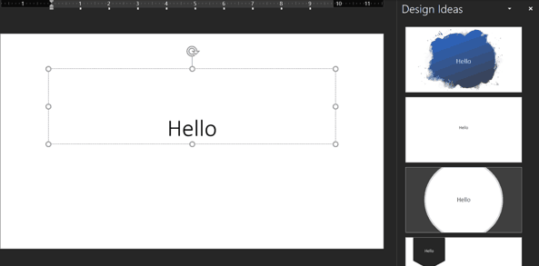

As you can see, it’s still the same text, but different design suggestions. So, if you’re not happy with the suggestions the first time around, try this technique. Perhaps the next round of design ideas may be more to your liking!

## 

## *Themes*

### **Purpose**

Used to select your favorite theme for the slide

### **Steps with pictures**

* Select the Design tab



* Then locate the Themes group. Each image represents a theme.



* Click the More drop-down arrow to see all available themes.

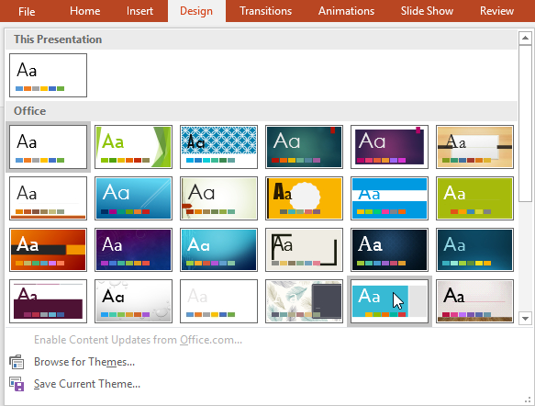

* Select the desired theme.
* The theme will be applied to the entire presentation. To apply a different theme, simply select it from the Design tab.

## *Color*

### **Purpose**

Used to change the color of a theme

### **Steps with pictures**

* Click on design tab



* Click Colors, and then click Customize Colors.

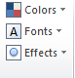

* Click the button next to the theme color you want to change
* Then pick a color under Theme Colors.

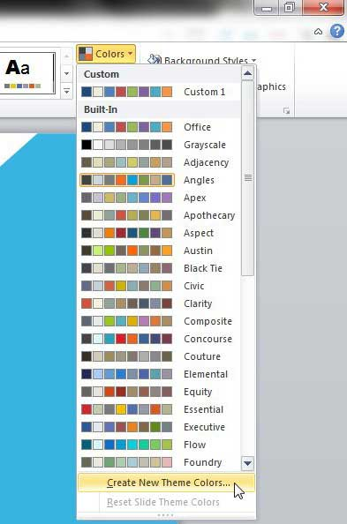

## *Font*

### **Purpose**

Used to change the font of the theme slide

### **Steps with pictures**

* Click on the design tab



* Click on font

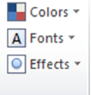

* Click on the font that you wanted to select

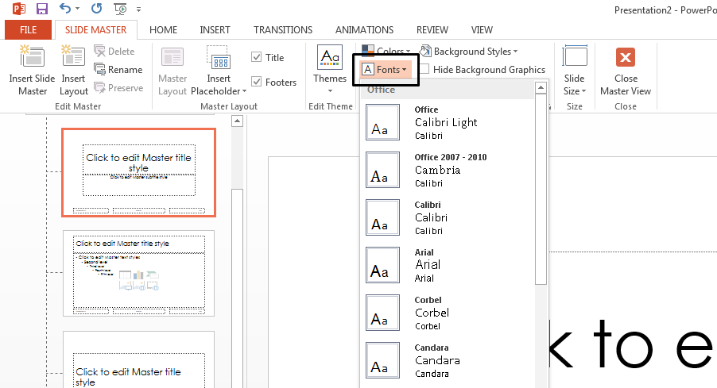

* Click okay

## *Effect*

### **Purpose**

Used to apply A effect on a theme

### **Steps with pictures**

* From the Design tab click the drop-down arrow in the Variants group and select Effects.



* Select the desired theme effects.

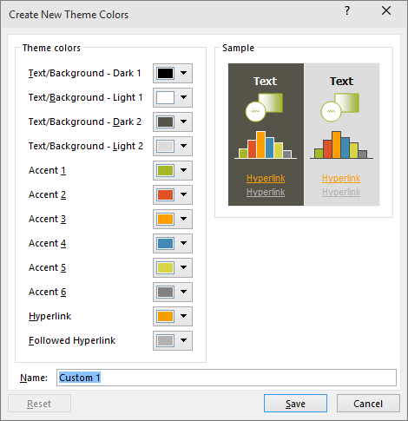

* Click on save to apply the changes

### Transitions Tab

#### Preview

|  |
| --- |
|  |

**Preview** - Preview the slide transitions for the active slide.

#### Transition to this slide

|  |
| --- |
|  |

Transition are used to make slide more productive.

**Transition Scheme** - gallery  
**Effect Options** -

**Transitions**

To add a special effect, to transition from one slide to another:

1. Select the slide you want to add a transition to.
2. On the **Transitions** tab, select the effect you want.
3. Select **Effect Options** to change how the transition happens: **From Right**, **From Left**, ...

To undo a transition, select **None**.

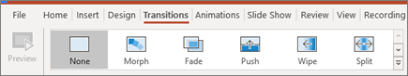

#### To apply a transition:

1. Select the **desired slide** from the **Slide Navigation** pane. This is the slide that will appear **after** the transition.

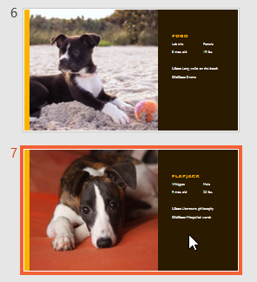

1. Click the **Transitions** tab, then locate the **Transition to This Slide** group. By default, **None** is applied to each slide.
2. Click the **More** drop-down arrow to display all transitions.

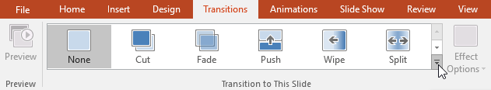

1. Click a**transition**to apply it to the selected slide. This will automatically preview the transition.

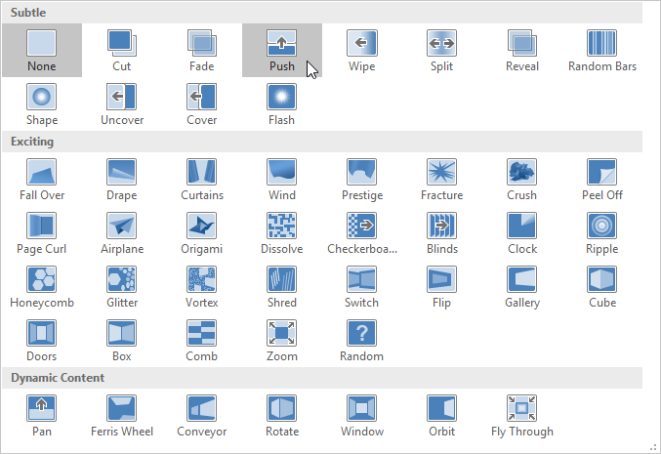

You can use the **Apply To All** command in the **Timing** group to apply the same transition to all slides in your presentation. Keep in mind that this will modify any other transitions you've applied.

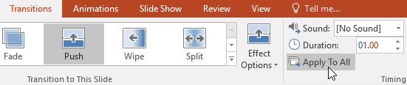

Try applying a few different types of transitions to various slides in your presentation. You may find that some transitions work better than others, depending on the content of your slides.

#### To preview a transition:

You can **preview** the transition for a selected slide at any time using either of these two methods:

* Click the **Preview** command on the **Transitions** tab.

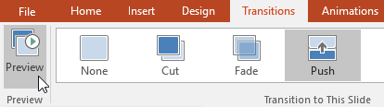

* Click the **Play Animations** command in the **Slide Navigation** pane.

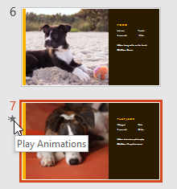

### Modifying transitions

#### To modify the transition effect:

You can quickly customize the look of a transition by changing its **direction**.

1. Select the **slide** with the transition you want to modify.
2. Click the **Effect Options** command and choose the desired option. These options will vary depending on the selected transition.

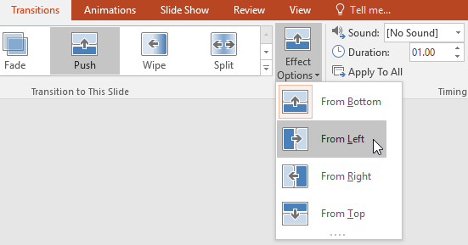

1. The transition will be **modified**, and a **preview** of the transition will appear.

Some transitions do not allow you to modify the direction.

#### To modify the transition duration:

1. Select the **slide** with the transition you want to modify.
2. In the **Duration** field in the **Timing** group, enter the **desired time** for the transition. In this example, we'll decrease the time to half a second—or 00.50—to make the transition **faster**.

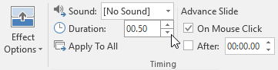

#### To add sound:

1. Select the **slide** with the transition you want to modify.
2. Click the**Sound** drop-down menu in the **Timing** group.
3. Click a **sound** to apply it to the selected slide, then preview the transition to hear the sound.

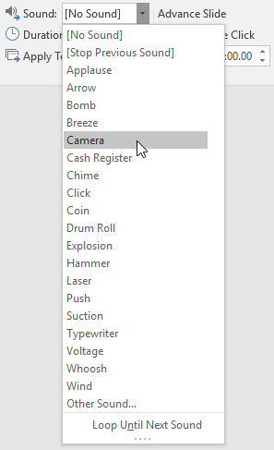

Sounds are best used in moderation. Applying a sound between every slide could become overwhelming or even annoying to an audience when presenting your slide show.

#### To remove a transition:

1. Select the **slide** with the transition you want to remove.
2. Choose **None** from the **Transition to This Slide** group. The transition will be removed.

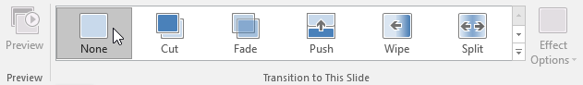

To remove transitions from **all slides**, apply the **None**transition to a slide, then click the **Apply to All** command.

#### Timing

|  |
| --- |
|  |

**Sound** – by use of this option we can enable sound to our slide when we moved one slide to next slide then it gives some sound on that moving.  
**Duration** -  
**Apply to All** - Set the transition between all the slides in the presentation to be the same as this slide.  
**On Mouse Click** - Lets you wait until there is a mouse click before moving on to the next slide.  
**After** -Lets you move to the next slide after a specific number of seconds.

**National University of Modern Languages**

Advancing in MS Power Point

# Week 7

**National University of Modern Languages Sector H-9, Islamabad, Pakistan.**



**Department of Software Engineering**

**Course Title: Introduction to Information & Computer Technology**

**Student Name: Hamza Mehmood**

**Roll Number: SP-21-110**

**Lab Number: WEEK 1-12 Date: 1 March to 3 June**

**Lab Assessment Rubrics**

**Method:** Lab report and instructor observation during Lab Session **Outcome Assessed:**

1. Ability to analyze and design solutions to conduct experiments (Psychomotor).
2. Ability to perform in a team (Affective).
3. Ability to apply and comprehend modern engineering tools to develop skills for engineering knowledge and being able to design report and documentation (Psychomotor).

|  |  |  |  |  |
| --- | --- | --- | --- | --- |
| **Performance** | **Exceeds Expectation (4-5)** | **Meets Expectation (2-3)** | **Does not meet Expectation (1)** | **Marks** |
| 1. Realization of  Experiment [c] | Chooses the required yet relevant equipment to perform the experiment establishes setup diagrams of equipment connection or wiring. | Effective guidance is required to choose relevant tools for the experiment and also to develop well connected wiring diagram. | Fails to select the required equipments/ tools to perform the experiment or wiring diagram seriously lack clarity or appear ambiguous. |  |
| 2. Teamwork [b] | An active cooperation develops among group members to support the execution of the experiment. | Effectively cooperates with the group members  to perform the experiment. | Negatively affects the other group members and creates hindrance in successful performance or completion of experiment. |  |
| 3. Conducting Experiment [a] | A careful selection of equipment, wiring is done under supervision of instructor for effective operation and task completion. | Carefully examines the  equipment, wiring of all components and calibrate experiments with very few errors. | Incapable of calibrating the suitable equipment and wiring with inaccurate equipment operation. |  |
| 4. Laboratory  Safety Rules [a] | Safety rules and procedures are carefully observed during the experiment. | Scrutiny observes the prescribed safety measures with very minor deviation. | Does not observe the safety rules during experiments. |  |
| 5. Data Collection  [a] | Data collection is carefully planned to achieve experimental objective. | Data collection is carefully planned to get experimental objectives with very minor mistakes. | Incapable of planning the data collection to acquire the experimental objective or the collected data is inappropriate or incomplete. |  |
| 6. Report writing  [c] | Properly written with all results. | Writing report with minor error. | Incomplete Lab report |  |

**Total Marks Obtained:**

**Instructor’s Signature:**

### Animations Tab

#### Preview

|  |
| --- |
|  |

**Preview** - Preview the slide animations for the active slide.

#### Animation

|  |
| --- |
|  |

**Animation Styles** - gallery  
**Effect Options** –

**Animations**

To animate text or objects on a slide:

1. Select the text or object you want to animate.
2. On the **Animations** tab, select **Add Animation**, and select the animation you want from the drop-down.

To animate one line of text at a time, select one line of text, select an animation, select the next line of text, select an animation, ...

1. For **Start**, select **When Clicked**, **With Previous**, or **After Previous**.

You can also select the **Duration** or **Delay**.

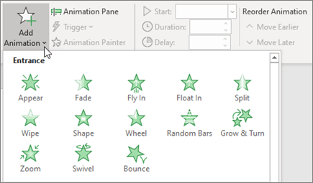

*Advanced Animation*

|  |
| --- |
|  |

**Add Animation** -  
**Animation Pane** -  
**Trigger** -  
**Animation Painter** –

1. Select the shape or object you want to add an animation to.
2. Go to **Animations** > **Advanced Animation** > **Add Animation** and select the animation you want to add.
3. Next, go to **Animations** > **Advanced Animation** > **Animation Pane**.

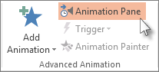

1. In the **Animation Pane**, select the animated shape or other object that you want to trigger to play when you click it.
2. In the **Advanced Animation** group, click **Trigger**, point to **On Click**, and then select the object.

### Trigger an animation to begin during a video or audio clip

To trigger an animation effect to play during a video or audio clip, you must first insert a bookmark at the desired point in the clip.

1. [Add a bookmark to your video or audio clip](https://support.microsoft.com/en-us/office/add-bookmarks-to-points-of-interest-in-audio-and-video-clips-eafb434f-5038-4c6a-93d0-428a9b68b7fa) for where you want to trigger an animation effect to begin.
2. Go to **Animations** > **Advanced Animation** > **Animation Pane**.
3. In the **Animation Pane**, select the animation effect that you want to begin at a certain point during the audio or video clip.
4. In the **Advanced Animation** group, click **Trigger**, point to **On Bookmark**, and select the bookmark that you want to trigger the animation to begin.

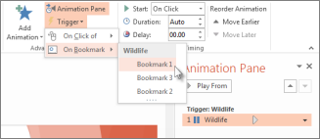

*Timing*

|  |
| --- |
|  |

**Start** -  
**Duration** - (Transition Speed in 2007)  
**Delay** -  
**Move Earlier** -  
**Move Later** -

Slide Show Tab

#### Start Slide Show

|  |
| --- |
|  |

**From Beginning** - Start the slide show from the first slide.  
**From Current Slide** - Start the slide show from the active slide.  
**Broadcast Slide Show** - (Removed in 2010).  
**Custom Slide Show** - Drop-Down. The drop-down contains the commands: Custom Shows. Custom Shows displays the "Custom Shows" dialog box.

#### Setup

|  |
| --- |
|  |

**Set Up Slide Show** - Displays the "Set Up Show" dialog box.  
**Hide Slide** - Hides the current slide from the slide show. Hidden slides are indicated in the top left corner.  
**Record Narration** - (Removed in 2010).  
**Rehearse Timings** - Launches a full screen slide show allowing you to rehearse the transitions.  
**Use Rehearsed Timing** - (Removed in 2010)  
**Record Style Show** -  
**Play Narrations** -  
**Use Timings** -  
**Show Media Controls** –

*Monitors*

|  |
| --- |
|  |

**Resolutions** - Displays a list of available resolutions.  
**Show On** - (Show Presentation On in 2007).  
**Use Presenter View** - Toggles the display of speaker view on a second monitor.

### Review Tab

#### Proofing

|  |
| --- |
|  |

**Spelling** - (F7) it is use for spelling checker.  
**Research** - Toggles the display of the Research task pane.  
**Thesaurus** - (Shift + F7). Toggles the display of the Research task pane defaulting the research service to the thesaurus.

*Window*

|  |
| --- |
|  |

**New Window** - Opens a new window containing a view of the current presentation.  
**Arrange All** - Tile all open windows side by side on the screen.  
**Cascade** - Cascade all the open windows so they overlap.  
**Move Split** - Move the splitters to separate the different parts of the window.  
**Switch Windows** - Drop-Down.

**New Window** To open a new PowerPoint window, click this button. A new window will open with the same presentation. The presentation will have a number after the name.

**Arrange All** Click this button to tile the open windows on the screen side-by-side.

**Cascade Use** this button to tile the open windows so that they overlap vertically on the screen.

Move Split This option is used to move the splitters that separate the different sections of the window.

**Switch Windows** Click this button to switch from one window to another window. A list of the open windows will display when the button is clicked.

**Macros**

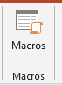

**Macros** These are miniature programs that are used to perform specified tasks within a program. Examples of Macros are Ctrl + P for print or Ctrl + S for save. When this button is clicked, a list of macros will be displayed.

**National University of Modern Languages**

Introduction to MS Excel

# Week 8

**National University of Modern Languages Sector H-9, Islamabad, Pakistan.**



**Department of Software Engineering**

**Course Title: Introduction to Information & Computer Technology**

**Student Name: Hamza Mehmood**

**Roll Number: SP-21-110**

**Lab Number: WEEK 1-12 Date: 1 March to 3 June**

**Lab Assessment Rubrics**

**Method:** Lab report and instructor observation during Lab Session **Outcome Assessed:**

1. Ability to analyze and design solutions to conduct experiments (Psychomotor).
2. Ability to perform in a team (Affective).
3. Ability to apply and comprehend modern engineering tools to develop skills for engineering knowledge and being able to design report and documentation (Psychomotor).

|  |  |  |  |  |
| --- | --- | --- | --- | --- |
| **Performance** | **Exceeds Expectation (4-5)** | **Meets Expectation (2-3)** | **Does not meet Expectation (1)** | **Marks** |
| 1. Realization of  Experiment [c] | Chooses the required yet relevant equipment to perform the experiment establishes setup diagrams of equipment connection or wiring. | Effective guidance is required to choose relevant tools for the experiment and also to develop well connected wiring diagram. | Fails to select the required equipments/ tools to perform the experiment or wiring diagram seriously lack clarity or appear ambiguous. |  |
| 2. Teamwork [b] | An active cooperation develops among group members to support the execution of the experiment. | Effectively cooperates with the group members  to perform the experiment. | Negatively affects the other group members and creates hindrance in successful performance or completion of experiment. |  |
| 3. Conducting Experiment [a] | A careful selection of equipment, wiring is done under supervision of instructor for effective operation and task completion. | Carefully examines the  equipment, wiring of all components and calibrate experiments with very few errors. | Incapable of calibrating the suitable equipment and wiring with inaccurate equipment operation. |  |
| 4. Laboratory  Safety Rules [a] | Safety rules and procedures are carefully observed during the experiment. | Scrutiny observes the prescribed safety measures with very minor deviation. | Does not observe the safety rules during experiments. |  |
| 5. Data Collection  [a] | Data collection is carefully planned to achieve experimental objective. | Data collection is carefully planned to get experimental objectives with very minor mistakes. | Incapable of planning the data collection to acquire the experimental objective or the collected data is inappropriate or incomplete. |  |
| 6. Report writing  [c] | Properly written with all results. | Writing report with minor error. | Incomplete Lab report |  |

**Total Marks Obtained:**

**Instructor’s Signature:**

# 

Microsoft Excel is a [spreadsheet](http://en.wikipedia.org/wiki/Spreadsheet) [application](http://en.wikipedia.org/wiki/Application_software) that is commonly used for a variety of uses. At its core, Excel is a table consisting of rows and columns. Excel is composed of rows and columns and uses a spreadsheet to display data. Features include: calculation, graphing tools, [pivot tables,](http://en.wikipedia.org/wiki/Pivot_table) and a macro programming language called [Visual Basic for Applications.](http://en.wikipedia.org/wiki/Visual_Basic_for_Applications)

What can I do with this?

The data within a table can be sorted by any column, which means that the rows can be ordered by last name or first name alphabetically, by the ID number ascending or descending, by the amount paid ascending or descending, or by the date. You can also filter the data in the table to have only specific values show.

What is a cell?

A cell, outlined in green below, is an individual block within a table in which you can enter values, such as words or numbers.

What are rows and columns?

Rows, outlined in red below, are a horizontal group of cells. Columns, outlined in blue below, are a vertical group of cells.

Inserting rows and columns

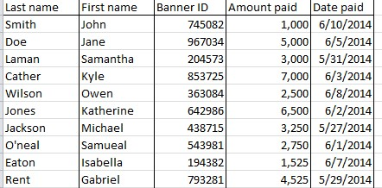

This is a row



This is a column

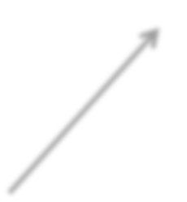

This is a cell

To Add a Row:

1. Select the entire row below where you want to add the new row.

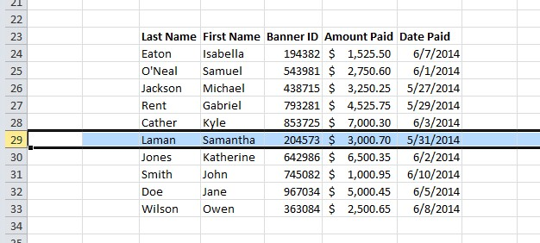

1. Right click, select Insert.

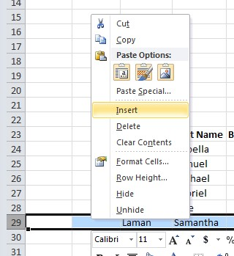

To Add a Column

1. Select the column to the right of where you want to add the new column

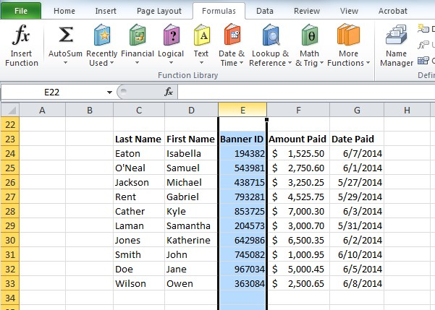

1. Right click, select Insert.

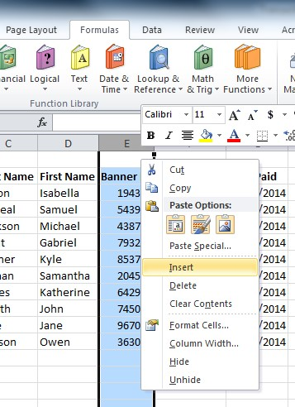

## Moving Between Cells

Use the arrow keys on your keyboard to move from one cell to another

Use the Tab key to move horizontally to the right. Hold the Shift key and press the Tab key to move horizontally to the left.

Use the Enter key to move vertically downward. Hold the Shift key and press the Enter key to move vertically upwards. Selecting Multiple Cells

To select a range of data:

1. Select the first cell in the data range.
2. Hold the Shift key.
3. Select the last cell in the data range.

OR

Select the beginning range of data, drag the cursor to select the range of data Selecting Entire Rows and Columns

Excel organizes a data sheet by numbering the rows and lettering the columns.

To select an entire row:

Select the number of the row

To select an entire column:

Select the letter of the column.

## Selecting Multiple Rows and Columns

To select multiple rows or columns

1. Select the entire first row
2. Hold the Shift Key
3. Select the entire last row of the range of data

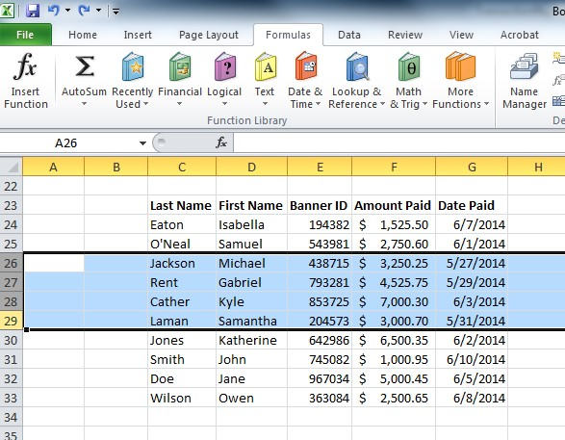

# Formatting

Formatting in Excel allows you to change the appearance of cells or the appearance of the spreadsheet as a whole.

## Cells

Formatting cells allow you to change the appearance of the value within the cell without changing the value, such as converting number into a currency or percentage value.

To Format a Cell:

1.

S

elect the cell or cells to forma

t

2.

Right click

and

select

*Format Cells*

.

The Format Cells dialogue box will appear

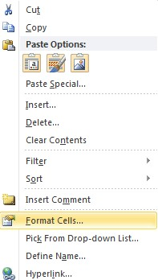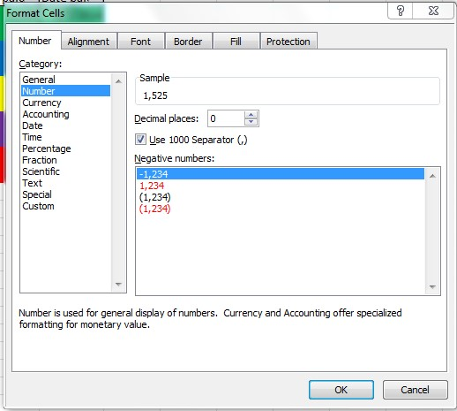

To convert a numeric value into an accounting value: Select Accounting from the list of Categories.

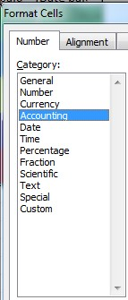

Click Ok.

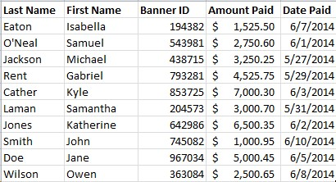

## Tables

A table is a way of formatting data so that data may be sorted. Tables also display rows in alternating colors to make the data easier to read.

### Choosing a TableStyle to Create a Table

To Choose a Table Style:

1. Select the range of cells to include in the table.

2.

Choose

*Table*

located on the Insert tab.

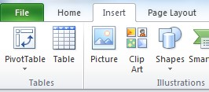

The Create Table dialogue box will appear.

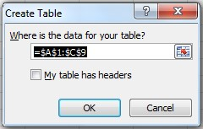

If you selected a range of data to include in the table, the table contents will already be populated in the *Where is the data for you table* field.

To include headers in the table, select the *My Table has Headers* checkbox.

To Create a Table from the Home Tab:

1. Select the range of cells to include in the table.

1. Select *Format as Table*.

1. Follow the steps listed above to create a table.

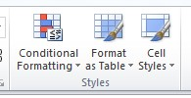

### Adjust the Table Style

Select the table, and choose the *Table Style* located on the Design tab.

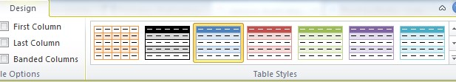

### Creating or Deleting a Custom Table Style

To Create a Custom Table:

1. Select your data

1. Choose *Format as Table*.

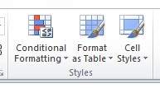

1. Select *New Table Style* at the bottom of the dropdown menu.

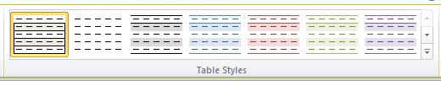

The New Table Quick Style dialogue box will appear.

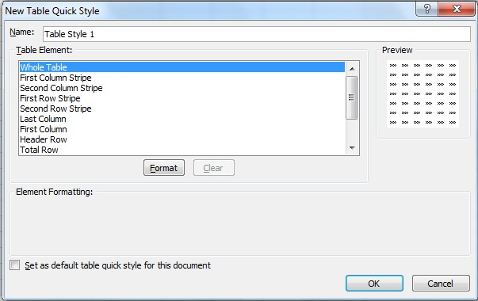

1. Select any of the table elements to format the table as desired.

The Preview box allows you to view the table before completing formatting changes. Select OK to apply the table to your data.

To Set this Table as a Default Table:

1. Select the *Set as default table quick style for this document* option

To Delete a Custom Style:

1. Select *Format as Table*.
2. Find the custom style located within the *Custom* section
3. Right click on the style, select *Delete*.

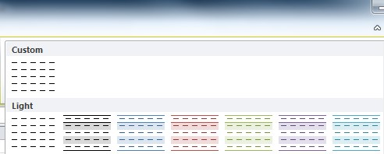

### Removing a Table Style

To Remove a Table Style from and Existing Table:

1.

Select the

contents of the

table

.

2.

Choose the

*More*

button

.

3.

Choose

*Clear*

.





This will clear the table style but the data will still remain in a table format.

### Converting a Table to a Range of Data

To Convert an Existing Table to a Range of Data:

1. Select the table.

2.

Select

*Convert to Range*

.

3.

Select

*Yes*

.

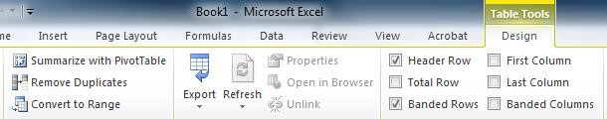

### Formatting Table Elements

To Format the Elements of a Table Style:

1. Select the contents of the table.
2. *Table Style Options* contains various table formatting options.

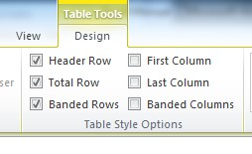

1. Select the desired checkboxes to change the format of the table.

*Header Row* – Creates a row at the top of the table for headers.

*Total Row* – Creates a row at the bottom of the table populates a total sum for each column.

*Banded Rows* – Shades every other row in the table.

*First Column* – Shades the entire first column the same color as the header row.

*Last Column* – Shades the entire last column the same color as the header row. *Banded Columns* – Shades every other column in the table.

**National University of Modern Languages**

Introduction to MS Excel

# Week 9

**National University of Modern Languages Sector H-9, Islamabad, Pakistan.**



**Department of Software Engineering**

**Course Title: Introduction to Information & Computer Technology**

**Student Name: Hamza Mehmood**

**Roll Number: SP-21-110**

**Lab Number: WEEK 1-12 Date: 1 March to 3 June**

**Lab Assessment Rubrics**

**Method:** Lab report and instructor observation during Lab Session **Outcome Assessed:**

1. Ability to analyze and design solutions to conduct experiments (Psychomotor).
2. Ability to perform in a team (Affective).
3. Ability to apply and comprehend modern engineering tools to develop skills for engineering knowledge and being able to design report and documentation (Psychomotor).

|  |  |  |  |  |
| --- | --- | --- | --- | --- |
| **Performance** | **Exceeds Expectation (4-5)** | **Meets Expectation (2-3)** | **Does not meet Expectation (1)** | **Marks** |
| 1. Realization of  Experiment [c] | Chooses the required yet relevant equipment to perform the experiment establishes setup diagrams of equipment connection or wiring. | Effective guidance is required to choose relevant tools for the experiment and also to develop well connected wiring diagram. | Fails to select the required equipments/ tools to perform the experiment or wiring diagram seriously lack clarity or appear ambiguous. |  |
| 2. Teamwork [b] | An active cooperation develops among group members to support the execution of the experiment. | Effectively cooperates with the group members  to perform the experiment. | Negatively affects the other group members and creates hindrance in successful performance or completion of experiment. |  |
| 3. Conducting Experiment [a] | A careful selection of equipment, wiring is done under supervision of instructor for effective operation and task completion. | Carefully examines the  equipment, wiring of all components and calibrate experiments with very few errors. | Incapable of calibrating the suitable equipment and wiring with inaccurate equipment operation. |  |
| 4. Laboratory  Safety Rules [a] | Safety rules and procedures are carefully observed during the experiment. | Scrutiny observes the prescribed safety measures with very minor deviation. | Does not observe the safety rules during experiments. |  |
| 5. Data Collection  [a] | Data collection is carefully planned to achieve experimental objective. | Data collection is carefully planned to get experimental objectives with very minor mistakes. | Incapable of planning the data collection to acquire the experimental objective or the collected data is inappropriate or incomplete. |  |
| 6. Report writing  [c] | Properly written with all results. | Writing report with minor error. | Incomplete Lab report |  |

**Total Marks Obtained:**

**Instructor’s Signature:**

Merge Cells in Ms Excel:

Step 1

Select the cells you want to merge. Highlight them with your mouse or by starting in one cell, holding Shift, then using the arrows to select to the end.

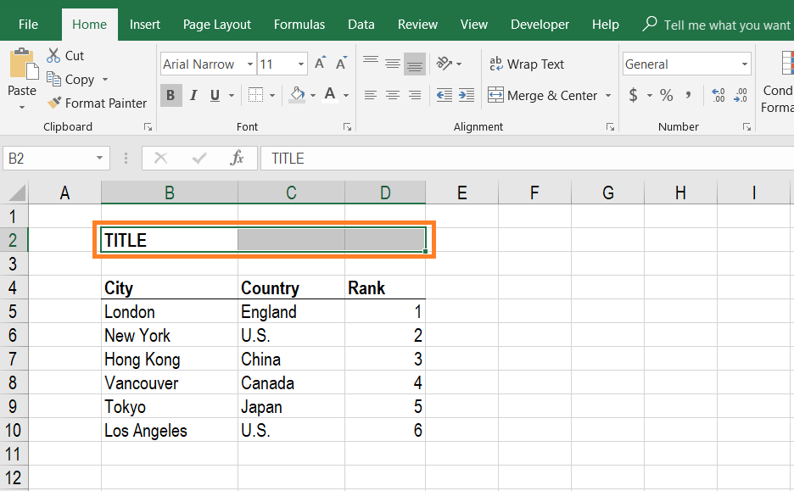

Step 2

On the Home Ribbon, select the Format Cells button, or press the keyboard shortcut Ctrl + 1 to open the Format Cells dialogue box.

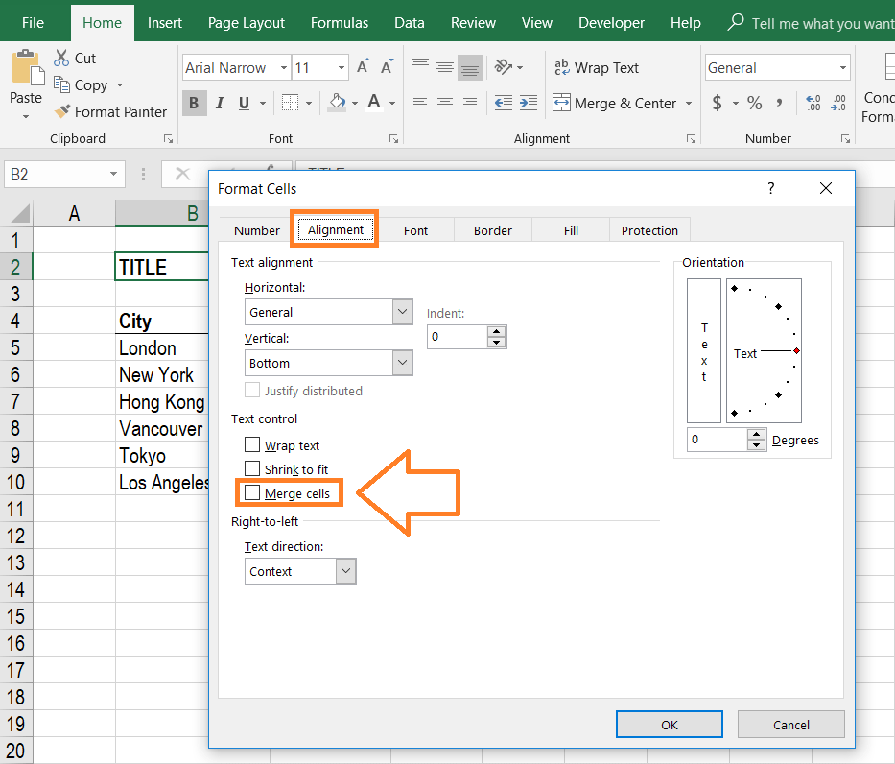

Step 3

Inside the Format Cells menu, click on the Alignment tab and tick the box that says Merge Cells.

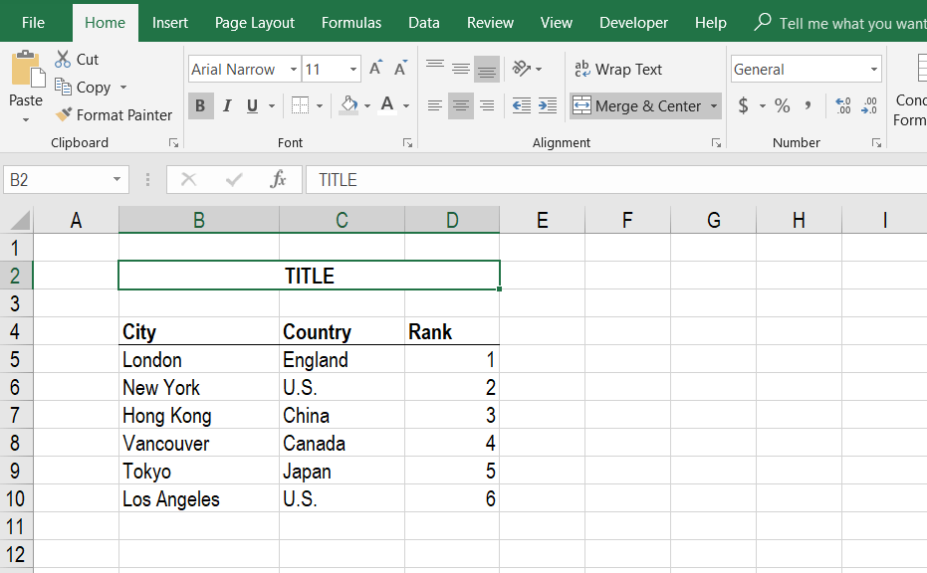

Step 4

Click center to place the title in the center of the merged cells and set a background color to make the title really stand out.

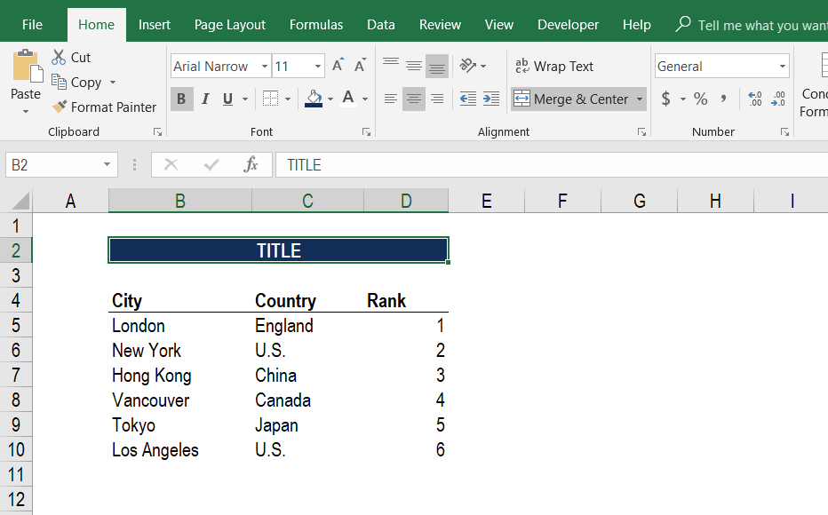

Then simply Merge the Cells

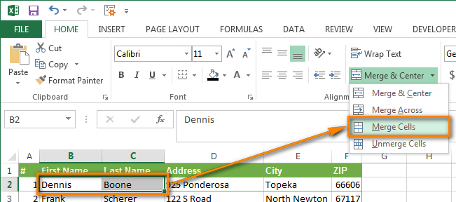

Group rows automatically (create an outline)

1. Select any cell in one of the rows you want to group.
2. Go to the Data tab > Outline group, click the arrow under Group, and select Auto Outline.

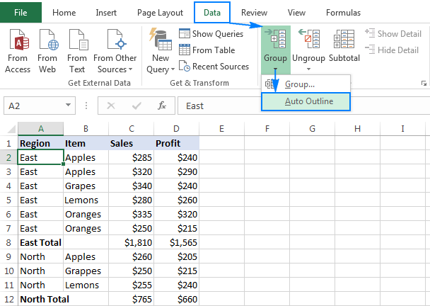

Ungroup all worksheets

When you’ve made all the changes, you can ungroup the worksheets.

1. Right-click any worksheet tab in the group.
2. Click Ungroup Sheets.

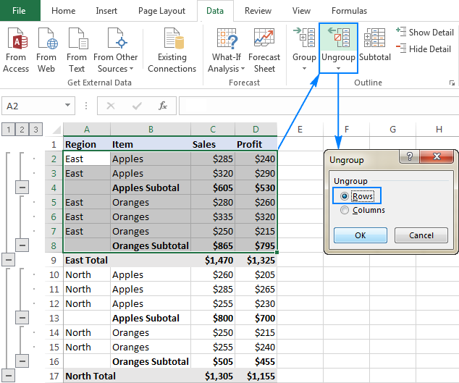

**National University of Modern Languages**

Introduction to MS Excel

# Week 10

**National University of Modern Languages Sector H-9, Islamabad, Pakistan.**



**Department of Software Engineering**

**Course Title: Introduction to Information & Computer Technology**

**Student Name: Hamza Mehmood**

**Roll Number: SP-21-110**

**Lab Number: WEEK 1-12 Date: 1 March to 3 June**

**Lab Assessment Rubrics**

**Method:** Lab report and instructor observation during Lab Session **Outcome Assessed:**

1. Ability to analyze and design solutions to conduct experiments (Psychomotor).
2. Ability to perform in a team (Affective).
3. Ability to apply and comprehend modern engineering tools to develop skills for engineering knowledge and being able to design report and documentation (Psychomotor).

|  |  |  |  |  |
| --- | --- | --- | --- | --- |
| **Performance** | **Exceeds Expectation (4-5)** | **Meets Expectation (2-3)** | **Does not meet Expectation (1)** | **Marks** |
| 1. Realization of  Experiment [c] | Chooses the required yet relevant equipment to perform the experiment establishes setup diagrams of equipment connection or wiring. | Effective guidance is required to choose relevant tools for the experiment and also to develop well connected wiring diagram. | Fails to select the required equipments/ tools to perform the experiment or wiring diagram seriously lack clarity or appear ambiguous. |  |
| 2. Teamwork [b] | An active cooperation develops among group members to support the execution of the experiment. | Effectively cooperates with the group members  to perform the experiment. | Negatively affects the other group members and creates hindrance in successful performance or completion of experiment. |  |
| 3. Conducting Experiment [a] | A careful selection of equipment, wiring is done under supervision of instructor for effective operation and task completion. | Carefully examines the  equipment, wiring of all components and calibrate experiments with very few errors. | Incapable of calibrating the suitable equipment and wiring with inaccurate equipment operation. |  |
| 4. Laboratory  Safety Rules [a] | Safety rules and procedures are carefully observed during the experiment. | Scrutiny observes the prescribed safety measures with very minor deviation. | Does not observe the safety rules during experiments. |  |
| 5. Data Collection  [a] | Data collection is carefully planned to achieve experimental objective. | Data collection is carefully planned to get experimental objectives with very minor mistakes. | Incapable of planning the data collection to acquire the experimental objective or the collected data is inappropriate or incomplete. |  |
| 6. Report writing  [c] | Properly written with all results. | Writing report with minor error. | Incomplete Lab report |  |

**Total Marks Obtained:**

**Instructor’s Signature:**

# Functions and Formulas

## Basic Functions/Formulas

Excel has many different functions and formulas which can be used to manipulate data in a variety of ways, such as sums, subtotals, averages, number counts, maximums, and minimums.

### Sums

One of the most commonly used functions of Excel is summation. If you have a data table for a single student with amounts and dates of payment, to find the sum of all payments, you would use the summation function.

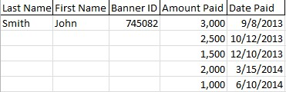

To add numbers in a column:

1.

S

elect the cell directly

beneath

the last entry.

2.

S

elect

*Auto Sum*

locat

ed on the

*Formulas*

tab.

3.

Select the

*AutoSum*

button

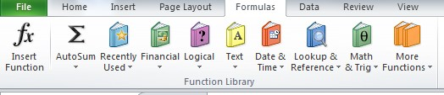

1. This will select all items within the column
2. Click the *Enter* key on your keyboard to calculate the sum of all fields.

Other functions are available by selecting the AutoSum dropdown

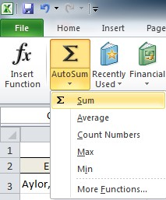

Other functions include: averaging the numbers in a column, counting the numbers in a column and finding the minimum and/or maximum numbers in the column.

Additionally, there is an *AutoSum* button and dropdown menu also located on the Home toolbar.

Subtotaling

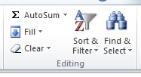

The Subtotal tool is used sum data by group. Subtotaling data eliminates the need to manually insert a row and perform a summation.

Below is a sample data sheet for which we need to calculate the total amount paid for each semester.

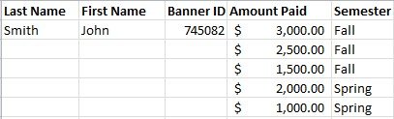

### One Level Subtotals

To Subtotal a data sheet:

1. Select the *Subtotal* button located on the Data toolbar.

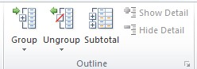

The Subtotal dialogue box will open

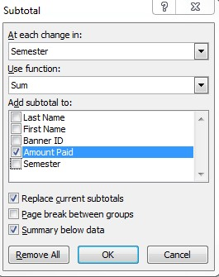

To subtotal this data sheet by semester:

1. Choose *Semester* for the *At Each Change* In dropdown.
2. Select *Sum* for the *Use Function* dropdown.
3. Choose *Amount Paid* for the *Add Subtotal To* field.
4. Click *Ok*.

Subtotals will automatically be added to your data.

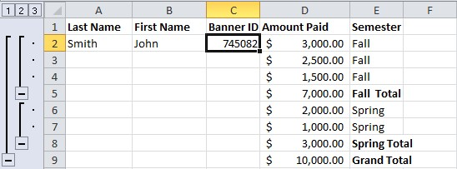

The subtotal hierarchy located to the left of the spreadsheet can be used to hide some of the data within the spreadsheet.

To view only the grand total, select column 1

To view the total for each subsection, select column 2 To view all data, select column 3.

### Nested Level Subtotals

Nested Level Subtotals are used to subtotal more than one level of data.

For this example our list of data contains individual payers and semesters

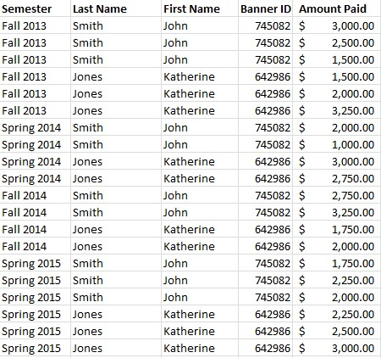

1. Select any cell within your range of data
2. Select *Subtotal* on the Data tab.

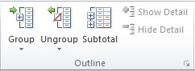

The Subtotal dialogue box will open.

1. For the *At Each Change* in dropdown menu, select *Semester*.
2. Choose to *Use Function*, *Sum*.
3. Choose to *Add Subtotal To*, *Amount Paid*.

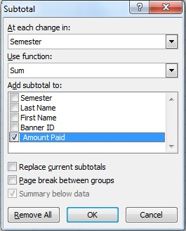

1. Click *Ok*.

The first level of subtotal will be added to the data.

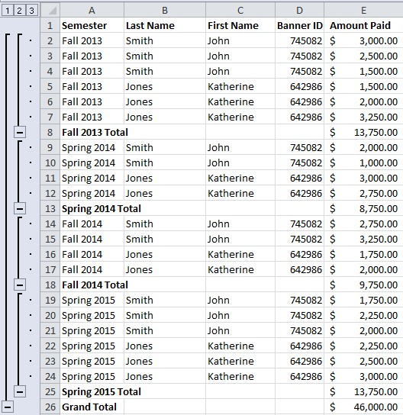

To add an additional level of subtotals:

1. Select *Subtotal*
2. For the *At Each Change* in dropdown menu, select *Last Name*.
3. Choose to *Use Function*, *Sum*.
4. Choose to *Add Subtotal To*, *Amount Paid*.
5. Ensure the checkbox *Replace Current Subtotals* is unchecked.

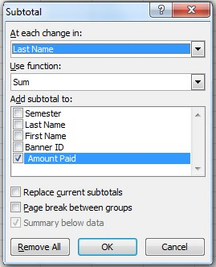

1. Click *Ok*.

The second level of subtotals will be added to the data range:

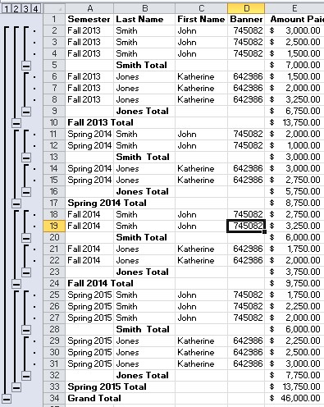

### Removing Subtotals

To remove subtotals from a data sheet:

1. Select the *Subtotal t*ool

The Subtotal Dialogue box will appear.

1. Select *Remove All* to remove all subtotals.

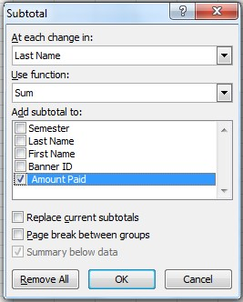

#### Average

To find the average of a select range of data:

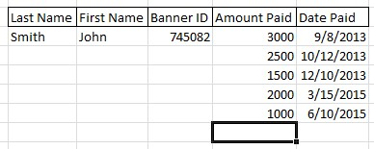1. Select the cell directly beneath the range of data

2.

Select the

*Auto Sum*

dropdown on the Formulas tab.

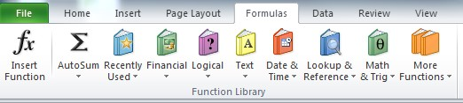

3. Choose *Average* from the Auto Sum dropdown

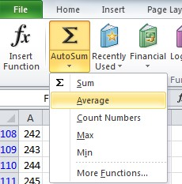

4.

Select the range of cells to calculate

5.

Click

*Enter*

on your keyboard

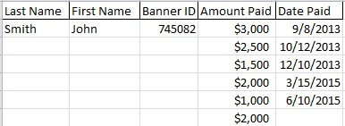

#### Count Numbers

To count the number of items in a range of data:

1. Select the cell directly beneath the range of data.



1. Select the *Auto Sum* dropdown.
2. Select *Count Numbers*.

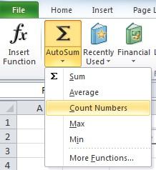

1. Select the range of cells to calculate.
2. Click *Enter* on your keyboard.

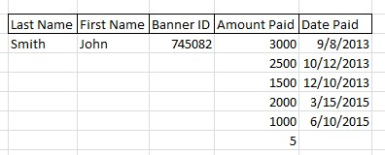

#### Maximum and Minimum

To calculate the Maximum or Minimum for a range of data:

1. Select the cell directly beneath the range of data.



1. Select the *Auto Sum* dropdown.
2. Select *Max* or *Min* to calculate the maximum or minimum values

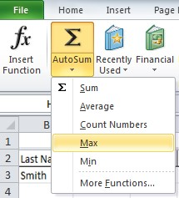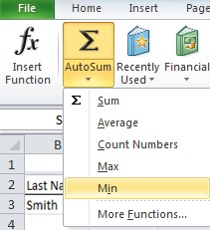

1. Select the range of cells to calculate.
2. Click *Enter* on your keyboard to calculate the value.

**National University of Modern Languages**

Introduction to MS Excel

# Week 11

**National University of Modern Languages Sector H-9, Islamabad, Pakistan.**



**Department of Software Engineering**

**Course Title: Introduction to Information & Computer Technology**

**Student Name: Hamza Mehmood**

**Roll Number: SP-21-110**

**Lab Number: WEEK 1-12 Date: 1 March to 3 June**

**Lab Assessment Rubrics**

**Method:** Lab report and instructor observation during Lab Session **Outcome Assessed:**

1. Ability to analyze and design solutions to conduct experiments (Psychomotor).
2. Ability to perform in a team (Affective).
3. Ability to apply and comprehend modern engineering tools to develop skills for engineering knowledge and being able to design report and documentation (Psychomotor).

|  |  |  |  |  |
| --- | --- | --- | --- | --- |
| **Performance** | **Exceeds Expectation (4-5)** | **Meets Expectation (2-3)** | **Does not meet Expectation (1)** | **Marks** |
| 1. Realization of  Experiment [c] | Chooses the required yet relevant equipment to perform the experiment establishes setup diagrams of equipment connection or wiring. | Effective guidance is required to choose relevant tools for the experiment and also to develop well connected wiring diagram. | Fails to select the required equipments/ tools to perform the experiment or wiring diagram seriously lack clarity or appear ambiguous. |  |
| 2. Teamwork [b] | An active cooperation develops among group members to support the execution of the experiment. | Effectively cooperates with the group members  to perform the experiment. | Negatively affects the other group members and creates hindrance in successful performance or completion of experiment. |  |
| 3. Conducting Experiment [a] | A careful selection of equipment, wiring is done under supervision of instructor for effective operation and task completion. | Carefully examines the  equipment, wiring of all components and calibrate experiments with very few errors. | Incapable of calibrating the suitable equipment and wiring with inaccurate equipment operation. |  |
| 4. Laboratory  Safety Rules [a] | Safety rules and procedures are carefully observed during the experiment. | Scrutiny observes the prescribed safety measures with very minor deviation. | Does not observe the safety rules during experiments. |  |
| 5. Data Collection  [a] | Data collection is carefully planned to achieve experimental objective. | Data collection is carefully planned to get experimental objectives with very minor mistakes. | Incapable of planning the data collection to acquire the experimental objective or the collected data is inappropriate or incomplete. |  |
| 6. Report writing  [c] | Properly written with all results. | Writing report with minor error. | Incomplete Lab report |  |

**Total Marks Obtained:**

**Instructor’s Signature:**

Protecting the Workbook:

1. Select File > Info.
2. Select the Protect Workbook box and choose Encrypt with Password.
3. Enter a password in the Password box, and then select OK.
4. Confirm the password in the Reenter Password box, and then select OK.

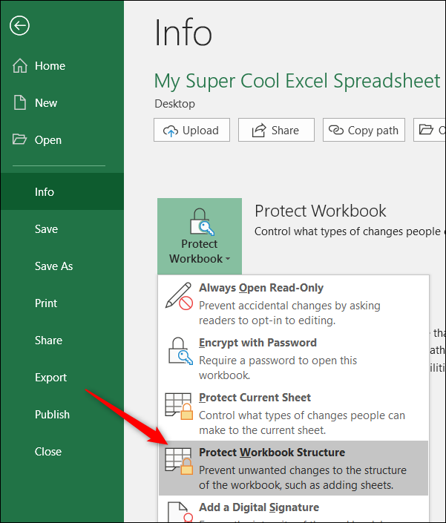

Efficient use of LOOKUP functions in Excel:

LOOKUP:

The most commonly used LOOKUP functions in Excel are VLOOKUP and HLOOKUP. VLOOKUP allows you to search a data range that is set up vertically. HLOOKUP is the exact same function, but looks up data that has been formatted by rows instead of columns.

VLOOKUP:

VLOOKUP searches for a value in the leftmost column of a data range, and then returns a value in the same row from a column you specify in the range. VLOOKUP is used instead of HLOOKUP when your comparison values are located in a column to the left of the data you want to find.

The syntax for VLOOKUP is VLOOKUP (lookup_value, table_array, col_index_num, range_lookup)

‘range_lookup’: If TRUE (or omitted), an approximate match is returned (i.e., if an exact match is not found, the next largest value that is less than ‘lookup_value’ is returned). If FALSE, VLOOKUP will find an exact match.

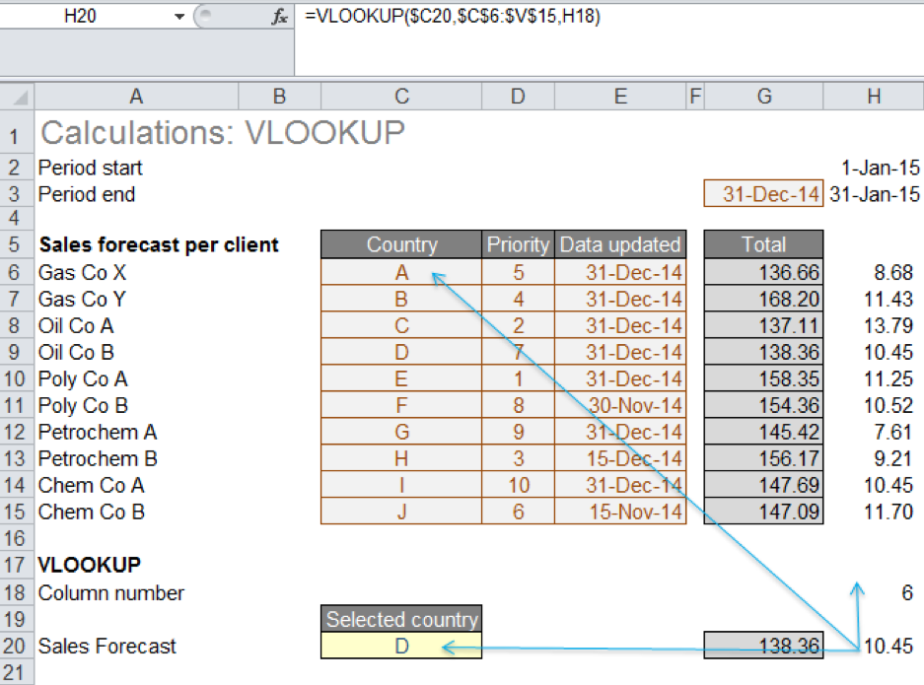

HLOOKUP:

HLOOKUP performs the same function as VLOOKUP, but looks up data that has been formatted by rows. HLOOKUP searches for a value in the top row of a table (or an array of values), and then returns a value in the same column from a row you specify in the table or array.

The syntax for HLOOKUP is HLOOKUP (lookup value, table array, row_index_num, range lookup)

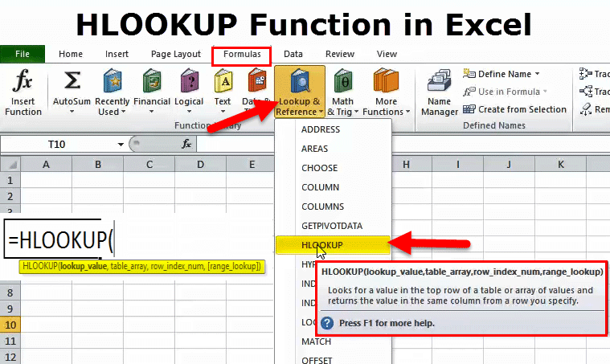

THE USE OF INDEX(MATCH):

As described above, VLOOKUP and HLOOKUP functions have certain drawbacks that could lead to potential errors, especially for users unfamiliar with the model. Although the simple LOOKUP function could sometimes be used to replace VLOOKUP/HLOOKUP, it is limited to a single row or column to hold results. In some cases, using a combination of INDEX(MATCH) functions may be the only solution, as they are more robust and versatile than VLOOKUP/HLOOKUP.

**National University of Modern Languages**

Introduction to MS Excel

# Week 12

**National University of Modern Languages Sector H-9, Islamabad, Pakistan.**



**Department of Software Engineering**

**Course Title: Introduction to Information & Computer Technology**

**Student Name: Hamza Mehmood**

**Roll Number: SP-21-110**

**Lab Number: WEEK 1-12 Date: 1 March to 3 June**

**Lab Assessment Rubrics**

**Method:** Lab report and instructor observation during Lab Session **Outcome Assessed:**

1. Ability to analyze and design solutions to conduct experiments (Psychomotor).
2. Ability to perform in a team (Affective).
3. Ability to apply and comprehend modern engineering tools to develop skills for engineering knowledge and being able to design report and documentation (Psychomotor).

|  |  |  |  |  |
| --- | --- | --- | --- | --- |
| **Performance** | **Exceeds Expectation (4-5)** | **Meets Expectation (2-3)** | **Does not meet Expectation (1)** | **Marks** |
| 1. Realization of  Experiment [c] | Chooses the required yet relevant equipment to perform the experiment establishes setup diagrams of equipment connection or wiring. | Effective guidance is required to choose relevant tools for the experiment and also to develop well connected wiring diagram. | Fails to select the required equipments/ tools to perform the experiment or wiring diagram seriously lack clarity or appear ambiguous. |  |
| 2. Teamwork [b] | An active cooperation develops among group members to support the execution of the experiment. | Effectively cooperates with the group members  to perform the experiment. | Negatively affects the other group members and creates hindrance in successful performance or completion of experiment. |  |
| 3. Conducting Experiment [a] | A careful selection of equipment, wiring is done under supervision of instructor for effective operation and task completion. | Carefully examines the  equipment, wiring of all components and calibrate experiments with very few errors. | Incapable of calibrating the suitable equipment and wiring with inaccurate equipment operation. |  |
| 4. Laboratory  Safety Rules [a] | Safety rules and procedures are carefully observed during the experiment. | Scrutiny observes the prescribed safety measures with very minor deviation. | Does not observe the safety rules during experiments. |  |
| 5. Data Collection  [a] | Data collection is carefully planned to achieve experimental objective. | Data collection is carefully planned to get experimental objectives with very minor mistakes. | Incapable of planning the data collection to acquire the experimental objective or the collected data is inappropriate or incomplete. |  |
| 6. Report writing  [c] | Properly written with all results. | Writing report with minor error. | Incomplete Lab report |  |

**Total Marks Obtained:**

**Instructor’s Signature:**

### Pivot Tables

A pivot table is a data summarization tool within Excel. A pivot table can sort, count, total and average the data within a table or spreadsheet.

To Insert a Pivot Table:

1.

S

elect any cell in you

r

data range.

2.

Select Pivot Table located on the Insert tab.

The Create PivotTable

dialogue box

will appear.

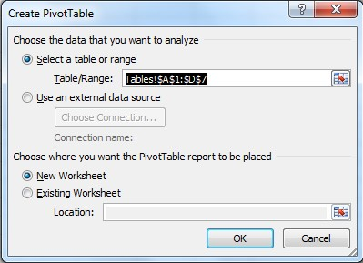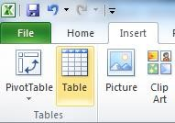

Excel will automatically select the data for the pivot table.

Excel will also automatically select New Worksheet as the destination for the pivot table.

1. Click *Ok*.

A new worksheet will be added for the pivot table.

Initially, the spreadsheet will appear blank.

The PivotTable Field List is located to the right.

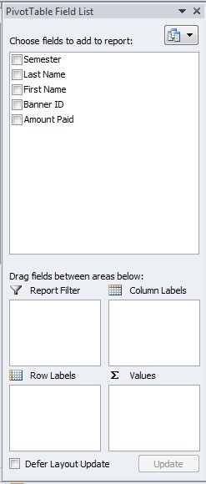

1. Choose the fields to see by selecting column headers within *Choose Field to Add to Report*.

You can also drag and drop a field into a Pivot table Area within the dialogue box.

Pivot Table Areas:

*Report Filter* – Filters the entire pivot table based on fields in that area

*Column Labels* – Adds columns to the table based on fields in that area;

*Row Labels* – Adds rows to the table based on fields in that area;

*Values* – Performs an Auto Sum action in the table based on the fields in that area.

In a pivot table, you can sort and filter like you can with any other data range.

To Change the Summary Calculation Value:

1. Click on any cell in the *Grand Total* row 2. Select *Value Field Settings* from the menu.

This will open the Value Field Settings dialogue box:

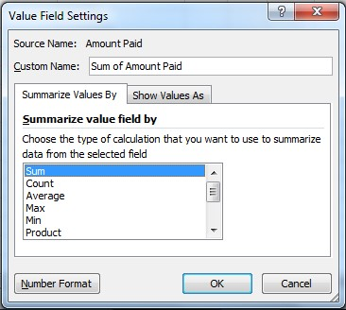

1. Choose the calculation you want to summarize.
2. Click *Ok*.

The *Values* field will change to the selected calculation.

END OF Lab Reports